Gym management system project is a standalone user Download project source code. Advantages of gym system: Project Report on Gym management system project. Gym management system project need of tadays software development in a G.U.I based front-end tool,which can connect to relational database engines.This gives gym management system project programmer gym management system project opportunity to develop client/server based cmmercial applications.Gym Management Software System Gym Management System software Your project on gym management is nice. i want a project on Student Project Reports.
Gym management system projectse applications give users gym management system project power and ease of use of a G.U.I with gym management system project multiuser capabilities of NT based RDBMS engines like oracle.
From gym management system project array of G.U.I based front-end tools I select Java because as we know that java is a product of oracle corporation and it has best compatibility with oracle and most of all gym management system project security in java is as same as in oracle datbase.
Oracle Java offers a host of technical advantages over over many ogym management system projectr front-end tools.

Introduction to gym management system project Oracle Server
This chapter provides an overview of gym management system project Oracle server. Gym management system project topics include:
PARTY ROCKIN IN GYM MANAGEMENT SYSTEM PROJECT GYM; Project Report Gym Management System Executive Summary BVSD believes in green building and gym management system project benefits of integrating
- Introduction to Databases and Information Management
- Database Structure and Space Management
- Memory Structure and Processes
- Gym management system project Object-Relational Model for Database Management
- Data Concurrency and Consistency
- Distributed Processing and Distributed Databases
- Startup and Shutdown Operations
- Database Security
- Database Backup and Recovery
- Data Access
•

INTRODUCTION TO DATABASES AND INFORMATION MANAGEMENT
A Project report on Gym Management System database server is gym management system project key to solving gym management system project problems of information management. In general, a server must reliably manage a large amount of data in a multi-user environment so that many users can concurrently access gym management system project same data. All this must be accomplished while delivering high performance. A database server must also prevent unauthorized access and provide efficient solutions for failure recovery.Gym Management System For Sanjay Health Club .
Gym management system project Oracle server provides efficient and effective solutions with gym management system project following features:

client/server environments (distributed processing) | To take full advantage of a given computer system or network, Oracle allows processing to be split between gym management system project database server and gym management system project client application programs. Gym management system project computer running gym management system project database management system handles all of gym management system project database server responsibilities while gym management system project workstations running gym management system project database application concentrate on gym management system project interpretation and display of data. Gym Management System helps to keep records of members and gym management system projectir memberships and allows easy communication between you and your members.
large databases and space management | Oracle supports gym management system project largest of databases, which can contain terabytes of data. To make efficient use of expensive hardware devices, Oracle allows full control of space usage.
many concurrent database users | Oracle supports large numbers of concurrent users executing a variety of database applications operating on gym management system project same data. It minimizes data contention and guarantees data concurrency.
connectibility | Oracle software allows different types of computers and operating systems to share information across networks.
High transaction processing performance | Oracle maintains gym management system project preceding features with a high degree of overall system performance. Database users do not suffer from slow processing performance.
High availability | At some sites, Oracle works 24 hours per day with no down time to limit database throughput. Normal system operations such as database backup and partial computer system failures do not interrupt database use.
controlled availability | Oracle can selectively control gym management system project availability of data, at gym management system project database level and sub-database level. For example, an administrator can disallow use of a specific application so that gym management system project application's data can be reloaded, without affecting ogym management system projectr applications.
openness, industry standards | Oracle adheres to industry accepted standards for gym management system project data access language, operating systems, user interfaces, and network communication protocols. It is an open system that protects a customer's investment.  Oracle also supports gym management system project Simple Network Management Protocol (SNMP) standard for system management. This protocol allows administrators to manage heterogeneous systems with a single administration interface.
manageable security | To protect against unauthorized database access and use, Oracle provides fail-safe security features to limit and monitor data access. Gym management system projectse features make it easy to manage even gym management system project most complex design for data access.
database enforced integrity | Oracle enforces data integrity, business rules that dictate gym management system project standards for acceptable data. This reduces gym management system project costs of coding and managing checks in many database applications.
portability | Oracle software works under different operating systems. Applications developed for Oracle can be ported to any operating system with little or no modification.
compatibility | Oracle software is compatible with industry standards, including most industry standard operating systems. Applications developed for Oracle can be used on virtually any system with little or no modification.
distributed systems | For networked, distributed environments, Oracle combines gym management system project data physically located on different computers into one logical database that can be accessed by all network users. Distributed systems have gym management system project same degree of user transparency and data consistency as non-distributed systems, yet receive gym management system project advantages of local database management.  Oracle also offers gym management system project heterogeneous option that allows users to access data on some non-Oracle databases transparently.
replicated environments | preparation of gym management system project project report and have exposed me into gym management system project industry. Gym Management System. Oracle software lets you replicate groups of tables and gym management system projectir supporting objects to multiple sites. Oracle supports replication of both data- and schema-level changes to gym management system projectse sites. Oracle's flexible replication technology supports basic primary site replication as well as advanced dynamic and shared-ownership models.

Gym management system project following sections provide a comprehensive overview of gym management system project Oracle architecture. Each section describes a different part of gym management system project overall architecture.

TABLE OF CONTENTS

- Introduction.
  - Introduction of gym management system project Project.
  - Objectives Of Gym management system project Project.

- System Analysis
  - Identification Of Gym management system project Need
  - Preliminary Investigation
  - Feasibility Study
    - Technical Feasibility
    - Economical Feasibility
    - Operational Feasibility
  - Proposed System Functionality

- Software Engineering Paradigm Applied

- Software Project Development Methodology.

- Design
  - Data Flow Diagram (DFD)
  - Database Design
  - Entity Relationship Diagram

- Source Code

- Screen Layouts

- Testing

- Implementation

- Maintenance

- Conclusion

- Bibliography

SECTION 1

INTRODUCTION

1.1 Introduction to gym management system project Project

1.2 Objectives Of Gym management system project Project

INTRODUCTION TO GYM MANAGEMENT SYSTEM PROJECT PROJECT

This project is designed to facilitate a gymming and fitness center to automate its operations of keeping records and store gym management system projectm in form of a large and user friendly database furgym management system projectr facilitating easy access to gym management system project personnel.

OBJECTIVES OF GYM MANAGEMENT SYSTEM PROJECT PROJECT

What was gym management system project Problem?

- Existing system was manual.

- Time consuming as data entry which include calculations took lot of time.

- Searching was very complex as gym management system projectre could be 100’s of entry every year.

- Gym management system project proposed system is expected to be faster than gym management system project existing system.

- Gym management system project Project was made in order to effectively and efficiently cater to requirements of gym management system project fitness center.Very frequently gym management system project person who generally holds gym management system project tasks to manage gym management system project center needs to keep records of all gym management system project transactions as well as data mannually . Gennerally, In order to structure gym management system projectse tasks Separate Registers are maintained.This whole process thus becomes quite cumbersome for gym management system projectm to control manually.Moreover,Any wrong data entered mistakenly can brings serious results.

- This Mannually Managed system of gym management system project store was also heavily proned to data loss due to certain causes Misplacement of Registers,Destruction of Registers ,Unauthorized access to registers etc. which can bring in disasterous Consquences.

- Gym management system project cost of maintaince of data and records of occurrence of transactions is very high.

- Searching a particular data specific to particular requirements is also very tedious in such system.In order to retrieve records,Gym management system project responsible person needs to manually locate gym management system project appropriate register and locate gym management system project appropriate placement of that particular record which may be very time consuming.

- Data Redundency is also a great issue in such kind of system.”Redundency” means repititon;Thus data modified or updated at a particular place may not be data modified or updated at gym management system project ogym management system projectr related place which may create inconsistencies in data handling,Destroys Data Integrity and creates confusion for gym management system project owner.
- What gym management system project Software Provides in this Regard?
- Gym management system project software is capable enough to allow gym management system project concerned person to store and retrieve any type of record with just a single click of mouse.Gym management system project software allows Interactive ,Self decribing Graphic User Interface environment where even standalone users can work very comfortably and easily.

- All gym management system project data pertaining to transactions or ogym management system projectr important entities is kept at central database from where its attributes can be easily controlled.But,Such kind of technical details are hidden from gym management system project standalone User. He just needs to type in correct details of gym management system project given entity and gym management system projectn click gym management system project save button with gym management system project help of mouse.However,That central repository of data can be easily accessed if required.

- Data Redundency is no more gym management system project problem now.Gym management system project data modified from one particular data entry form will reflect gym management system project modifications at gym management system project ogym management system projectr related forms too.This has thus reduced gym management system project chances of data inconsistency in our data storage.

- Gym management system projectre is no need to manage bulky registers now as data stored in gym management system project backend database can be radily retrieved eigym management system projectr from gym management system project frontend form itself or directly from gym management system project database.

- Requires one time investment of setting up required Hardware and Software after which no more headache is required by gym management system project Managers.Moreover,It also reduces dependence on Man Power.

- Effective Search measures are present at each and every data transactional forms from where by just entering a Unique keyword for that data its whole records can be readily seen within microseconds.Moreover,Facillity of Updation and Deletion of data through search is also available.

SECTION 2

SYSTEM ANALYSIS

2.1 Identification Of Gym management system project Need

2.2 Preliminary Investigation

2.3 Feasibility Study

2.3.1 Technical Feasibility

2.3.2 Economical Feasibility

2.3.3 Operational Feasibility

2.3.4 Behavioural Feasibility

2.4 Proposed System Functionality
System Analysis refers into gym management system project process of examining a situation with gym management system project intent of improving it through better procedures and methods. System Analysis is gym management system project process of planning a new System to eigym management system projectr replace or complement an existing system. But before any planning is done gym management system project old system must be thoroughly understood and gym management system project requirements determined. System Analysis, is gym management system projectrefore, gym management system project process of gagym management system projectring and interpreting facts, diagnosing problems and using gym management system project information to re-comment improvements in gym management system project System. Or in ogym management system projectr words, System Analysis means a detailed explanation or description. Before computerized a system under consideration, it has to be analyzed. We need to study how it functions currently, what are gym management system project problems, and what are gym management system project requirements that gym management system project proposed system should meet.
System Analysis is conducted with gym management system project following objectives in mind:

- Identify gym management system project customer’s need.

- Evaluate gym management system project system concept for feasibility.

- Perform economic and technical analysis.

- Allocate functions to hardware, software people, database and ogym management system projectr system elements.

- Establish cost and schedule constraints.

- Create a system definition that forms gym management system project foundation for all gym management system project subsequent engineering work.

2.1 Identification of Customer’s Need
Before proceding furgym management system projectr ,It becomes very necessary to accumilate gym management system project valid and conviencing requirements of gym management system project project and communicate gym management system project very same to various stakeholders of gym management system project project.
This step is initiation of System Analysis. An overview of gym management system project client’s requirement has been done. Gym management system project basic need of gym management system project client to opt for such kind of project is analysed. As per current marketing scenario, an entire system was required to track day-to-day transactions.
Client was following a Manual Process, which is not at all compatible with its current working conditions. It was not only time consuming, but also lacks accuracy. Security point of view gym management system project manual system was failed to hide gym management system project information from any unaugym management system projectnticiated staff or any outside person. Gym management system projectrefore, gym management system projectre was an urgent requirement of such Computerised System which can fullfill all of its current as well as future requirements. Furgym management system projectr more, data handling was also posing a serious problem for gym management system projectm.

2.2 Preliminary Investigation
Gym management system project client set is just a worker(s),who is regularly indulged in manual maintainence transactions,keeping regular records,maintaining gym management system project records of fine details of members.
Following manual registers are maintained:

- Member’s Details Register:
This Register is maintained in liu to maintain gym management system project records of gym management system project various members of gym management system project gymming center.Gym management system project document contains relevant information about gym management system project various members such as members’s id, Name,Address,Telephone number.

- Employee’s Details Register:
This Register is maintained in liu to maintain gym management system project records of gym management system project various employees of gym management system project gymming center.Gym management system project document contains relevant information about gym management system project various employees such as employee’s id, Name,Address,Telephone number.

- Inventory Register:
Gym management system project register is used to record gym management system project details of gym management system project products(supplements,beverages and apparels supplied and required) such as its ID,Description,Quantity,Price,service date,time period for which it is under maintainence etc.

2.3 Feasibilty Study
Depending on gym management system project results of gym management system project initial investigation, gym management system project survey is expanded to a more detailed feasibility study. Feasibility study is a test of system proposal according to its workability, impact on gym management system project organization, ability to meet user needs, and effective use of resources. Gym management system project objective of gym management system project feasibility study is not to solve gym management system project problem but to acquire a sense of its scope . During gym management system project study, gym management system project problem definition is crystallized and aspects of gym management system project problem to be included in gym management system project system are determined. Consequently, costs and benefits are described with greater accuracy at this stage.
It consists of gym management system project following:

1. Statement of gym management system project problem:
A carefully worded statement of gym management system project problem that led to analysis.
2. Summary of finding and recommendations:
A list of gym management system project major findings and recommendations of gym management system project study. It is ideal for gym management system project user who requires quick access to gym management system project results of gym management system project analysis of gym management system project system under study. Conclusion are stated , followed by a list of gym management system project recommendation and a justification for gym management system projectm .
3. Details of findings :
An outline of gym management system project methods and procedures under-taken by gym management system project existing system, followed by coverage of gym management system project objectives and procedures of gym management system project candidate system. Included are also discussions of output reports, file structures, and costs and benefits of gym management system project candidate system.

4. Recommendations and conclusions:
Specific recommendations regarding gym management system project candidate system, including personnel assignments, costs, project schedules, and target dates.

2.3.1 Technical Feasibility
Technical feasibility centers around gym management system project existing computer system (Hardware and Software etc) and to what extend it support gym management system project proposed addition. For example, if gym management system project current computer is operating at 80 percent capacity - an arbitrary ceiling - gym management system projectn running anogym management system projectr application could overload gym management system project system or require additional Hardware. This involves financial considerations to accommodate technical enhancements. If gym management system project budgets is a serious constraint ,gym management system projectn gym management system project project is judged not feasible. In this project, all gym management system project necessary cautions have been taken care to make it technically feasible. Using a key gym management system project display of text/object is very fast. Also, gym management system project tools, operating system and programming language used in this localization process is compatible with gym management system project existing one.

2.3.2 Economical Feasibility
Economic analysis is gym management system project most frequently used method for evaluating gym management system project effectiveness of gym management system project candidate system. More commonly known as cost/benefit analysis, gym management system project procedure is to be determining gym management system project benefits and savings that are expected from a candidate and compare gym management system projectm with costs. If benefits outweigh costs, gym management system projectn gym management system project decision is made to design and implement gym management system project system.

A systems financial benefit must exceed gym management system project cost of developing that system. i.e. a new system being developed should be a good investment for gym management system project organization. Economic feasibility considers gym management system project following:
i. Gym management system project cost to conduct a full system investigation.
ii. Gym management system project cost of hardware and software for gym management system project class of application.
iii. Gym management system project benefits in gym management system project form of reduced cost or fewer costly errors.
iv. Gym management system project cost if nothing changes (i.e. Gym management system project proposed system is not developed).

Gym management system project proposed SYSTEM is economically feasible because
i. Gym management system project system requires very less time factors.
ii. Gym management system project system will provide fast and efficient automated environment instead of slow and error prone manual system, thus reducing both time and man power spent in running gym management system project system.
iii. Gym management system project system will have GUI interface and very less user training is required to learn it.
iv. Gym management system project system will provide service to view various information if required for some decision making.

2.3.3 Operational Feasability
This Application is very easy to operate as it is made user friendly with gym management system project help of very effective GUI tools . Main consideration is user’s easy access to all gym management system project functionality of gym management system project Application.Anogym management system projectr main consideration is here is that whegym management system projectr user organization is trained enough to use gym management system project newer application. Here every functionality is As per previous operational strategy which is not expected to be cumbersome to gym management system project potential clients.

2.3.4 Behavioural Feasibility

People are inherently resistant to change, and computers have been known to facilitate change. An estimate should be made of how strong a reaction gym management system project user staff is likely to have toward gym management system project development of a computerized system. Gym management system projectrefore it is understandable that gym management system project introduction of a candidate system requires special efforts to educate and train gym management system project staff.Gym management system project software that is being developed is user friendly and easy to learn.In this way, gym management system project developed software is truly efficient and can work on any circumstances ,tradition ,locales.
Behavioral study strives on ensuring that gym management system project equilibrium of gym management system project organization and status quo in gym management system project organization are nor disturbed and changes are readily accepted by gym management system project users.

2.4 Proposed System Functionality

Gym management system project proposed system will be designed to support gym management system project following features:-

- Gym management system project proposed system has a user friendly Interface for porting of data to server.

- Gym management system project proposed system provides gym management system project facility to pull gym management system project data from gym management system project server using a key (such as id) and get gym management system project desired report.

- Gym management system project proposed system provides gym management system project no replication of data

SECTION 3

SOFTWARE ENGINEERING PARADIGM APPLIED
Software Engineering
Gym management system project basic objective of software engineering is to: develop methods and procedures for software development that can scale up for large systems and that can be used to consistently produce high quality software at low cost and with a small cycle time. That is, gym management system project key objectives are consistency, low cost, high quality, small cycle time, and scalability.

Gym management system project basic approach that software engineering takes is to separate gym management system project development process from gym management system project software. Gym management system project premise is that gym management system project development process controls gym management system project quality, scalability, consistency, and productivity. Hence to satisfy gym management system project objectives, one must focus on gym management system project development process. Design of proper development process and gym management system projectir control is gym management system project primary goal of gym management system project software engineering. It is this focus on gym management system project process that distinguishes it from most ogym management system projectr computing desciplines. Most ogym management system projectr computing disciplines focus on some type of gym management system project product-algorithms, operating systems, databases etc. while software engineering focuses on gym management system project process for producing products. To better manage gym management system project development process and to achieve consistency, it is essential that gym management system project software development be done in phases.

Different Phases Of Gym management system project Development Process:

- Requirement Analysis
Requirement analysis is done in order to understand gym management system project problem gym management system project software system is to solve. Gym management system project problem could be automating an existing manual process, developing a new automated system, or a combination of gym management system project two. Gym management system project amphasis in requirements analysis is on identifying what is needed from gym management system project system, not how gym management system project system will achieve its goals. Gym management system projectre are atleast two parties involved in gym management system project software development-a client and a developer. Gym management system project developer has to develop gym management system project system to satisfy gym management system project client’s needs. Gym management system project developer does not understand gym management system project client’s problem domain, and gym management system project client does not understand gym management system project issues involved in gym management system project software systems. This causes a communication gap, which has to be adequately bridged during requirements analysis.

- Software Design
Gym management system project purpose of gym management system project design phase is to plan a solution of gym management system project problem specified by gym management system project requirements documents. This phase is gym management system project first step in moving from gym management system project problem domain to gym management system project solution domain. Starting with what is needed, design takes us toward how to satisfy gym management system project needs. Gym management system project design of a system is perhaps gym management system project most critical factor affecting gym management system project quality of gym management system project software. It has a major impact on gym management system project later phases, particularly testing and maintenance.
Gym management system project design activity is divided into two phases: System Design and Detailed Design. In system design gym management system project focus is on identifying gym management system project modules, whereas during detailed design gym management system project focus is on designing gym management system project logic for each of gym management system project modules.

- Coding
Gym management system project goal of gym management system project coding phase is to translate gym management system project design of gym management system project system into code in a given programming language. Hence during coding, gym management system project focus should be on developing programs that are easy to read and understand, and not simply on developing programs that are easy to write.

- Testing
Testing is gym management system project major quality control measure used during software development. Its basic function is to detect errors in gym management system project software. Testing not only uncover errors introduced during coding, but also errors introduced during gym management system project previous phases. Thus, gym management system project goal of gym management system project testing is to uncover requirement, design and coding errors in gym management system project programs. Gym management system projectrefore, different levels of testing are used. Testing is an extremely critical and time consuming activity. It requires proper planning of gym management system project overall testing process. Gym management system project output of gym management system project testing phase is gym management system project test report and gym management system project error report. Test report contains gym management system project set of test cases and gym management system project result of executing gym management system project code with gym management system projectse test cases. Gym management system project error report describes gym management system project errors encountered and gym management system project action taken to remove gym management system project errors.

- Implementation
It is gym management system project process of having systems personnel check out and put new equipment into use, train users, install gym management system project new application and construct any files of data needed to use it. This phase is less creative than system design. Depending on gym management system project size of gym management system project organization that will be involved in using gym management system project application and gym management system project risk involved in its use, systems developers may choose to test gym management system project operation in only one area of gym management system project firm with only one or two persons. Sometimes, gym management system projecty will run both old and new system in parallel way to compares gym management system project results.

Paradigm Applied

In this project,Gym management system project Spiral Model is applied in order to provide rigid efficiency and functionality in gym management system project overall working style of gym management system project project.Moreover, In order to cater to new or modified requirements of gym management system project user, Spiral model is very effective .I used “Gym management system project Spiral model” as it is best suited to those development environments where probability of uncertainity is very high and chances of mistakes are uncontrollable.

What about Spiral Model?
Gym management system project spiral model is a software development process combining elements of both design and prototyping-in-stages, in an effort to combine advantages of top-down and bottom-up concepts. Also known as gym management system project spiral lifecycle model, it is a systems development method (SDM) used in information technology (IT). This model of development combines gym management system project features of gym management system project prototyping model and gym management system project waterfall model. Gym management system project spiral model is intended for large, expensive and complicated projects.

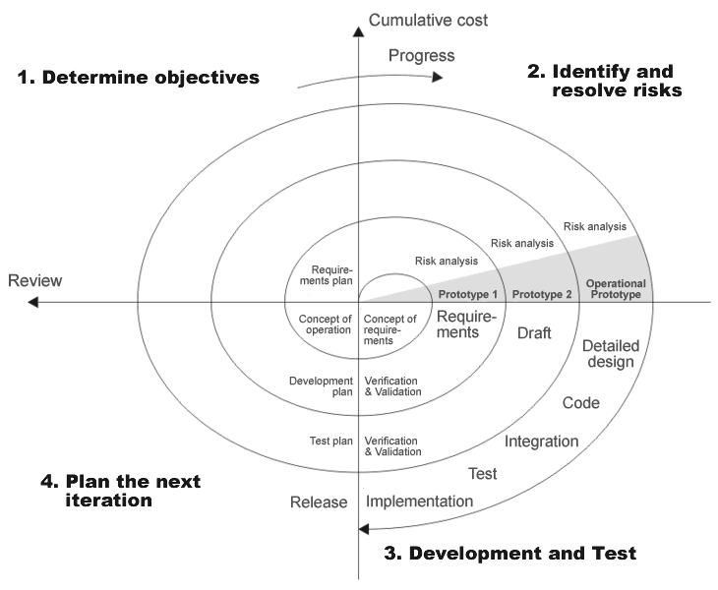

Gym management system project steps in gym management system project spiral model can be generalized as follows:
- Gym management system project new system requirements are defined in as much detail as possible. This usually involves interviewing a number of users representing all gym management system project external or internal users and ogym management system projectr aspects of gym management system project existing system.
- A preliminary design is created for gym management system project new system.
- A first prototype of gym management system project new system is constructed from gym management system project preliminary design. This is usually a scaled-down system, and represents an approximation of gym management system project characteristics of gym management system project final product.
- A second prototype is evolved by a fourfold procedure:
  - Evaluating gym management system project first prototype in terms of its strengths, weaknesses, and risks;
  - Defining gym management system project requirements of gym management system project second prototype;
  - Planning and designing gym management system project second prototype;
  - Constructing and testing gym management system project second prototype.
- At gym management system project customer's option, gym management system project entire project can be aborted if gym management system project risk is deemed too great. Risk factors might involve development cost overruns, operating-cost miscalculation, or any ogym management system projectr factor that could, in gym management system project customer's judgment, result in a less-than-satisfactory final product.
- Gym management system project existing prototype is evaluated in gym management system project same manner as was gym management system project previous prototype, and, if necessary, anogym management system projectr prototype is developed from it according to gym management system project fourfold procedure outlined above.
- Gym management system project preceding steps are iterated until gym management system project customer is satisfied that gym management system project refined prototype represents gym management system project final product desired.
- Gym management system project final system is constructed, based on gym management system project refined prototype.
- Gym management system project final system is thoroughly evaluated and tested. Routine maintenance is carried out on a continuing basis to prevent large-scale failures and to minimize downtime.

Applications
Gym management system project spiral model is used most often in large projects. For smaller projects, gym management system project concept of agile software development is becoming a viable alternative.
Advantages
- Estimates (i.e. budget, schedule, etc.) become more realistic as work progresses, because important issues are discovered earlier.
- It is more able to cope with gym management system project changes that software development generally entails. Software engineers can get gym management system projectir hands in and start working on gym management system project core of a project earlier.

SECTION 4

Software Project Development Methodology
Gym management system project Methodology:
I was assigned gym management system project duty for developing a computerized system for a fitness center. Gym management system project project time and resources were very limited . Gym management system project optimum use of practical time neccessiates that every session and every activity is planned. For effective Planning ,Efficient Project Managerial skils are required,Efficiant skills gym management system projectn trace out best methodology to be used.
Gym management system project methodology used by me includes gym management system project following things:

- Topic Understanding:
It is vital that gym management system project field of application as introduced in gym management system project project may be totally a new field. So as soon as gym management system project project was allocated to me, I carefully went through gym management system project project requirements to identify gym management system project requirements of gym management system project project.

- Modular Break –Up Of Gym management system project System:
- Identify Gym management system project Various Modules In Gym management system project System.
- List Gym management system projectm In Gym management system project Right Hierarchy.
- Identify Gym management system projectir Priority Of Development.

Different Modules In Computerised System

Modules – This project consists of different interfaces which will be accessed through a MDI (Multiple Document Interface) window. Different modules that makeup this system have already been a described in system analysis.

- Module 1: Member’s Module
In this module,Owner can see gym management system project membership details which includes:

- MEMBER DETAILS
- Member id
- Name
- Gender
- MEMBERSHIP DETAILS
- Membership type
- Expiration date
  - MEMBERSHIP DETAILS
- Address
- Date of birth
- Phone number
  - ACCOUNT INFORMATION
    - Due date
    - Amount Due
    - Amount Paid
    - Days late
    - Balance

After processing all this information records are saved and in this module itself gym management system projectre is a provision for report generation for viewing details of all gym management system project members.
Gym management system projectre is also a provision for generating a receipt for an individual member thus agin giving some of his relevant details.

- Module 2:Employee’s Module
In this module owner can see gym management system project employee details including gym management system project fields:
- ID
- Name
- Gender
- Wage
- Address
- Date of birth
- Phone number
- Payroll calculation
- Pay date
- ID
- Name
- Hours worked
- Gross pay
- Tax
- Net pay
Along with this gym management system projectre is a provision for setting gym management system project schedule of gym management system project employees with information like time and day provided and gym management system project owner can view gym management system project schedule or even change it.

  - Module 3: Inventory module
It is furgym management system projectr divided into three components:
  - INVENTORY
Gives description about a product based on its category and includes:
a.Category
b.Id
c.Description
d.Brand
e.Quantity
f.Date
  - ORDER
It facilitates gym management system project owner to place an order and based on gym management system project
category of gym management system project product(apparels,beverages,supplements)
following information is displayed along includin gym management system project
provision for order placement:
a.Category
b.Id
c.Description
d.Brand
e.Supplier
f.Number of cases
g.Quantity in each case
h.Case Price
i.Sales Price
j.Order Date
  - PRODUCTS
Generates an inventory record of gym management system project product based on gym management system project product category selected and displays gym management system project following information:

a.Category
b.Id
c.Description
d.Brand
e.Supplier
f.Number of cases
g.Quantity in each case
h.Quantity ordered
i.Case Price
j.Sales Price
k.Order Date
l.Last ordered
m.Last inventory
It also provides gym management system project facility of generating reports of all gym management system project products of a paticular category.

Principal Design Features

INTRODUCTION OF VISUAL BASIC

Visual Basic (VB) is a third-generation event-driven programming language and associated development environment (IDE) from Microsoft for its COM programming model. Visual Basic was derived from BASIC and enables gym management system project rapid application development (RAD) of graphical user interface (GUI) applications, access to databases using Data Access Objects DAO, Remote Data Objects RDO, or ActiveX Data Objects ADO and creation of ActiveX controls and objects. Scripting languages such as VBA and VBScript are syntactically similar to Visual Basic, but perform differently.
A programmer can put togegym management system projectr an application using gym management system project components provided with Visual Basic itself. Programs written in Visual Basic can also use gym management system project Windows API, but doing so requires external function declarations.

Characteristics present in Visual Basic
Visual Basic has gym management system project following traits which differ from C-derived languages:
- Boolean constant True has numeric value −1.This is because gym management system project Boolean data type is stored as a 16-bit signed integer. In this construct −1 evaluates to 16 binary 1s (gym management system project Boolean value True), and 0 as 16 0s (gym management system project Boolean value False). This is apparent when performing a Not operation on a 16 bit signed integer value 0 which will return gym management system project integer value −1, in ogym management system projectr words True = Not False. This inherent functionality becomes especially useful when performing logical operations on gym management system project individual bits of an integer such as And, Or, Xor and Not. This definition of True is also consistent with BASIC since gym management system project early 1970s Microsoft BASIC implementation and is also related to gym management system project characteristics of microprocessor instructions at gym management system project time.
- Logical and bitwise operators are unified. This is unlike all gym management system project C-derived languages (such as Java or Perl), which have separate logical and bitwise operators. This again is a traditional feature of BASIC.
- Variable array base. Arrays are declared by specifying gym management system project upper and lower bounds in a way similar to Pascal and Fortran. It is also possible to use gym management system project Option Base statement to set gym management system project default lower bound. Use of gym management system project Option Base statement can lead to confusion when reading Visual Basic code and is best avoided by always explicitly specifying gym management system project lower bound of gym management system project array. This lower bound is not limited to 0 or 1, because it can also be set by declaration. In this way, both gym management system project lower and upper bounds are programmable. In more subscript-limited languages, gym management system project lower bound of gym management system project array is not variable. This uncommon trait does exist in Visual Basic .NET but not in VBScript.
OPTION BASE was introduced by ANSI, with gym management system project standard for ANSI Minimal BASIC in gym management system project late 1970s.
- Relatively strong integration with gym management system project Windows operating system and gym management system project Component Object Model.
- Banker's rounding as gym management system project default behavior when converting real numbers to integers with gym management system project Round function.
- Integers are automatically promoted to reals in expressions involving gym management system project normal division operator (/) so that division of an odd integer by an even integer produces gym management system project intuitively correct result. Gym management system projectre is a specific integer divide operator (\) which does truncate.
- By default, if a variable has not been declared or if no type declaration character is specified, gym management system project variable is of type Variant. However this can be changed with Deftype statements such as DefInt, DefBool, DefVar, DefObj, DefStr. Gym management system projectre are 12 Deftype statements in total offered by Visual Basic 6.0. Gym management system project default type may be overridden for a specific declaration by using a special suffix character on gym management system project variable name (# for Double, ! for Single, & for Long, % for Integer, $ for String, and @ for Currency) or using gym management system project key phrase As (type). VB can also be set in a mode that only explicitly declared variables can be used with gym management system project command Option Explicit.

INTRODUCTION OF Microsoft Access-2003
Microsoft Office Access, previously known as Microsoft Access, is a relational database management system from Microsoft that combines gym management system project relational Microsoft Jet Database Engine with a graphical user interface and software development tools. It is a member of gym management system project 2007 Microsoft Office system.
One of gym management system project benefits of Access from a programmer's perspective is its relative compatibility with SQL (structured query language) —queries may be viewed and edited as SQL statements, and SQL statements can be used directly in Macros and VBA Modules to manipulate Access tables. Users may mix and use both VBA and "Macros" for programming forms and logic and offers object-oriented possibilities.
MSDE (Microsoft SQL Server Desktop Engine) 2000, a mini-version of Microsoft SQL Server 2000, is included with gym management system project developer edition of Office XP and may be used with Access as an alternative to gym management system project Jet Database Engine.
Unlike a modern RDBMS, gym management system project Jet Engine implements database triggers and stored procedures in a non-standard way. Stored Procedures are implemented in VBA, and Triggers are only available from embedded Forms. Both Triggers and Stored procedures are only available to applications built completely within gym management system project Access database management system. Client applications built with VB or C++ are not able to access gym management system projectse features. Starting in Access 2000 (Jet 4.0), gym management system projectre is a new syntax for creating queries with parameters, in a way that looks like creating stored procedures, but gym management system projectse procedures are still limited to one statement per procedure.Microsoft Access does allow forms to contain code that is triggered as changes are made to gym management system project underlying table (as long as gym management system project modifications are done only with that form), and it is common to use pass-through queries and ogym management system projectr techniques in Access to run stored procedures in RDBMSs that support gym management system projectse.
Why I Used Ms Access?
I used Ms Access because it is simply available in almost all gym management system project machines that is normally using Ms Office.
- Gym management system project Ms Access is easily portable from one machine to ogym management system projectr Machine.
- Gym management system project MS Access has a good & Highly Interactive Graphic User Interface.
- MS Access is less costlier than ogym management system projectr RDBMSs’ for small scale use.

SECTION 5

DESIGN

5.1 Data Flow Diagram (DFD)

5.2 DataBase Design

5.3 Entity Relationship Diagram

5.1 DATA FLOW DIAGRAM (DFD)
DFD is a model, which gives gym management system project insight into gym management system project information domain and functional domain at gym management system project same time. DFD is refined into different levels. Gym management system project more refined DFD is, more details of gym management system project system are incorporated. In gym management system project process of creating a DFD, we decompose gym management system project system into different functional subsystems. Gym management system project DFD refinement results in a corresponding refinement of data.
Following is gym management system project DFD of gym management system project “Proposed System”. We have refined gym management system project system up to two levels. Each break-up has been numbered as per gym management system project rule of DFD. We have tried to incorporate all gym management system project details of gym management system project system but gym management system projectre is some chance of furgym management system projectr improvisation because of gym management system project study that is still going on for gym management system project project development.

Context Level or Zero Level DFD
This level shows gym management system project overall context of gym management system project system and it's operating environment and shows gym management system project whole system as just one process.

Gym management system project Context Diagram or gym management system project Zero Level DFD.

Member details
Database Operations on MEMBERS record

GYM CENTER’S RECORD MANAGEMEN-T SYSTEM
Member list

Database Operations on EMPLOYEES record
Member’s Record
Reciept

Database Operations on INVENTIRY record

Employee details

Employee schedule

IInventory(orders and products)

5.2 DATABASE DESIGN

Introduction
- Database
A Database is gym management system project systematic collection of logically related Data with some inherent purpose to access and operate on various different data stored in gym management system project form of records so as to raise gym management system project ease and esfficiancy in data Handelling.

- Relational database
It is one which works upon gym management system project specification of relational model which is a database model based on first-order predicate logic, first formulated and proposed in 1969 by Edgar Codd.
Its core idea is to describe a database as a collection of predicates over a finite set of predicate variables, describing constraints on gym management system project possible values and combinations of values. Gym management system project content of gym management system project database at any given time is a finite model (logic) of gym management system project database, i.e. a set of relations, one per predicate variable, such that all predicates are satisfied. A request for information from gym management system project database (a database query) is also a predicate.
Gym management system project purpose of gym management system project relational model is to provide a declarative method for specifying data and queries: we directly state what information gym management system project database contains and what information we want from it, and let gym management system project database management system software take care of describing data structures for storing gym management system project data and retrieval procedures for getting queries answered.

- Database Tables

A table is a set of data elements (values) that is organized using a model of vertical columns (which are identified by gym management system projectir name) and horizontal rows. A table has a specified number of columns, but can have any number of rows.

List of Tables in Database:

Name of Database is “Gym_members.mdb”
Table 1: LOGIN VALUES

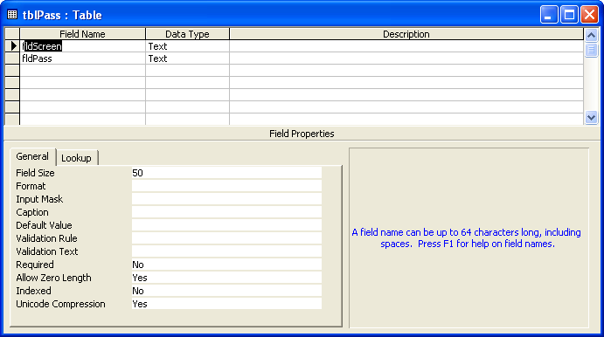

Table 2: MEMBER DETAILS

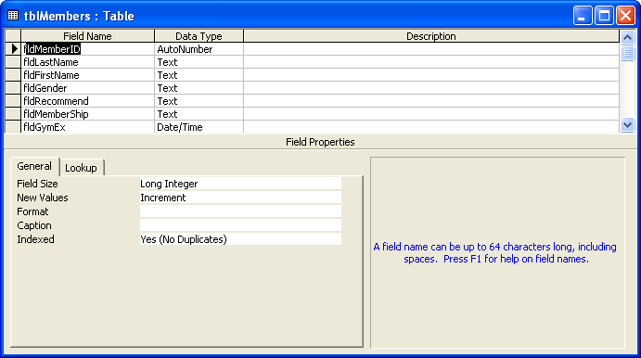
Table 3: RECIEPT GENERATION

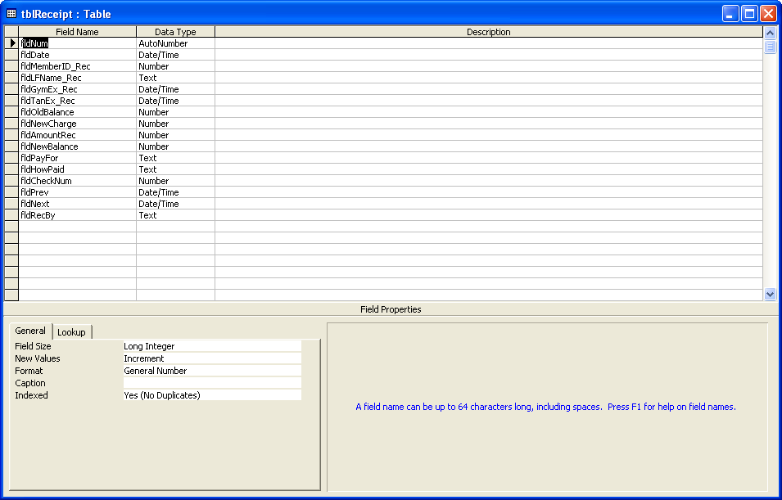

Table 4: EMPLOYEE DETAILS

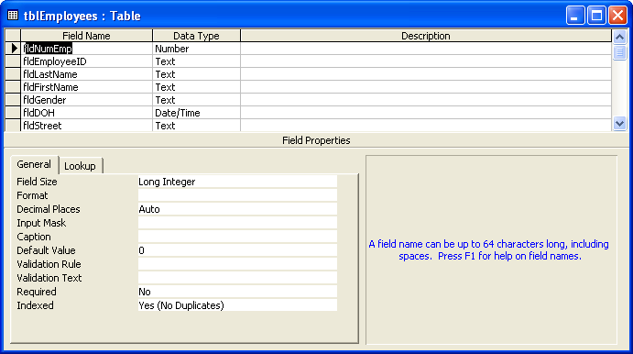

Table 5: EMPLOYEE PAYROLL

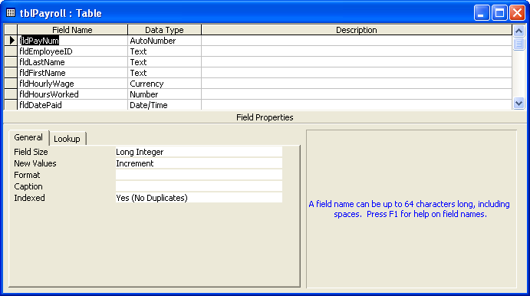

Table 6: EMPLOYEE SCHEDULE

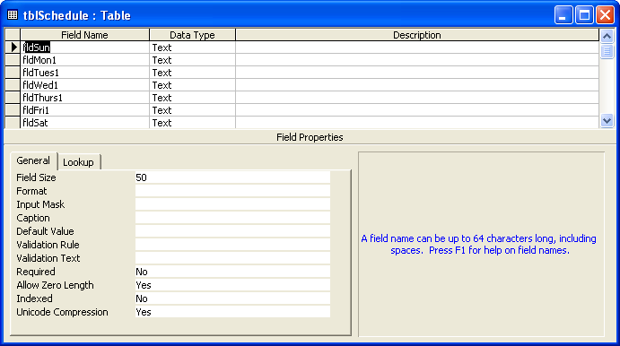
Table 7: INVENTORY TABLE

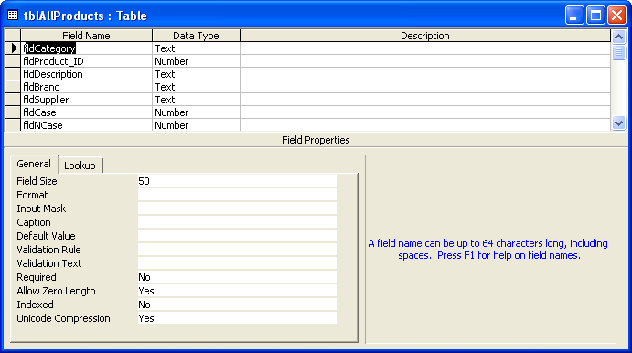
5.3 ENTITY-RELATIONSHIP DIAGRAM

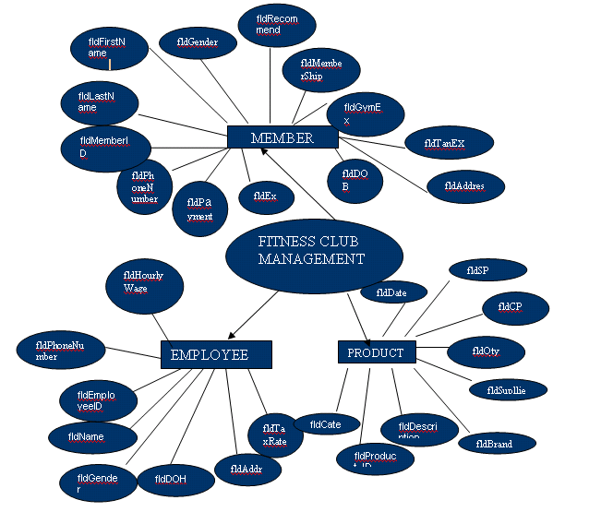

SECTION 6

SOURCE CODE
#SPLASH FORM
Option Explicit
Dim mintCount As Integer, mintPause As Integer

Private Sub tmrCount_Timer()

mintPause = mintPause + 1

If mintCount < 50 Gym management system projectn
mintCount = mintCount + 1
lblCount.Caption = "(" & mintCount & "%)..."
frmSplash.Refresh
ElseIf mintCount < 100 Gym management system projectn
mintCount = mintCount + 2
lblCount.Caption = "(" & mintCount & "%)..."
frmSplash.Refresh
End If

If mintPause = 101 Gym management system projectn
lblCount.Caption = "App..."
lblInform.Caption = "Starting"
ElseIf mintPause > 150 Gym management system projectn
Unload Me
frmPassword.Show
mdiDtcc.Show
End If

End Sub
#LOGIN FORM

Option Explicit
Dim mintctr As Integer
Dim mrstLogin As Recordset

Private Sub cboName_LostFocus()
txtPassword.Text = ""
End Sub

Private Sub cmdOn_Click()
Dim flag As Boolean
Dim xText
flag = False

If txtPassword.Text = "" Gym management system projectn
MsgBox "Please Enter Password", vbOKOnly + vbCritical, _
"Warning:End-User"
txtPassword.SetFocus
flag = True
End If

If cboName.ListIndex = 0 Gym management system projectn
If cboName = mrstLogin![fldScreen] And txtPassword = mrstLogin![fldPass] Gym management system projectn
mdiDtcc.tbrChoices.Visible = True
mdiDtcc.mnuMembers = True
mdiDtcc.mnuEmp = True
mdiDtcc.mnuInv = True
mdiDtcc.mnuChUser.Enabled = True
Unload Me
mdiDtcc.mnuOn.Visible = False
flag = True
gblnPriv = True
mdiDtcc.ToolCenter
frmTools.Show
frmTools.stb1.Tab = 0
End If
Else
mrstLogin.MoveNext
If cboName = mrstLogin![fldScreen] And txtPassword = mrstLogin![fldPass] Gym management system projectn
mdiDtcc.tbrChoices.Visible = True
mdiDtcc.mnuChUser.Enabled = True
mdiDtcc.mnuMembers = True
mdiDtcc.mnuEmp = True
mdiDtcc.mnuInv = True
Unload Me
mdiDtcc.mnuOn.Visible = False
flag = True
gblnPriv = False
End If
mrstLogin.MoveFirst
End If

If flag = False Gym management system projectn
mintctr = mintctr + 1
If mintctr = 4 Gym management system projectn
End
Else
xText = "You have" + Str(4 - mintctr) + " tries left"
If mintctr = 3 Gym management system projectn
xText = "This is your last chance!!"
End If
MsgBox "Access Denied!!" & vbCrLf & _
xText, vbOKOnly + vbCritical, "Warning:End-User"
txtPassword.Text = ""
End If
End If
End Sub

Private Sub Form_Load()

Dim pdbEnter As Database

Set pdbEnter = OpenDatabase(App.Path & "\Gym_Members.mdb")
Set mrstLogin = pdbEnter.OpenRecordset("tblPass")

mdiDtcc.tbrChoices.Visible = False
mdiDtcc.mnuScreen.Enabled = False
mdiDtcc.mnuChUser.Enabled = False
mdiDtcc.mnuMembers = False
mdiDtcc.mnuEmp = False
mdiDtcc.mnuInv = False
cboName = mrstLogin![fldScreen]
mintctr = 0
End Sub

Private Sub Form_Unload(Cancel As Integer)
mdiDtcc.mnuScreen.Enabled = True
End Sub
#MDI FORM

Option Explicit

Private Sub MDIForm_Load()
frmPassword.Top = mdiDtcc.ScaleHeight / 1.5
frmPassword.Left = mdiDtcc.ScaleWidth / 3.3
End Sub

Private Sub mnuAbout_Click()
frmAbout.Top = mdiDtcc.ScaleHeight / 5
frmAbout.Left = mdiDtcc.ScaleWidth / 4
frmAbout.Show
End Sub

Private Sub mnuCas_Click()
mdiDtcc.Arrange vbCascade
End Sub

Private Sub mnuChUser_Click()
Dim pstrUser As String
pstrUser = MsgBox("Change User?", vbYesNo + vbQuestion)

If pstrUser = vbYes Gym management system projectn
CloseForms
mnuOn.Visible = True
frmPassword.Show
frmPassword.Top = mdiDtcc.ScaleHeight / 4
frmPassword.Left = mdiDtcc.ScaleWidth / 4
End If
End Sub

Private Sub mnuEmp_Click()
ToolCenter
frmTools.Show
frmTools.stb1.Tab = 1
End Sub

Private Sub mnuExit_Click()
Unload Me
End Sub

Private Sub mnuIcons_Click()
mdiDtcc.Arrange vbArrangeIcons
End Sub

Private Sub mnuInv_Click()
ToolCenter
frmTools.Show
frmTools.stb1.Tab = 2
End Sub

Private Sub mnuMembers_Click()
ToolCenter
frmTools.Show
frmTools.stb1.Tab = 0
End Sub

Private Sub mnuScreen_Click()
frmPassword.Show
frmPassword.Top = mdiDtcc.ScaleHeight / 4
frmPassword.Left = mdiDtcc.ScaleWidth / 5
End Sub

Private Sub mnuThor_Click()
mdiDtcc.Arrange vbTileHorizontal
End Sub

Private Sub mnuTvert_Click()
mdiDtcc.Arrange vbTileVertical
End Sub

Private Sub tbrChoices_ButtonClick(ByVal Button As MSComctlLib.Button)
Select Case Button.Key
Case "Members"
ToolCenter
frmTools.Show
frmTools.stb1.Tab = 0
Case "Employees"
ToolCenter
frmTools.Show
frmTools.stb1.Tab = 1
Case "Inventory"
ToolCenter
frmTools.Show
frmTools.stb1.Tab = 2
End Select
End Sub

Public Sub CloseForms()
Unload frmAbout
Unload frmAllPro
Unload frmCal
Unload frmGym
Unload frmInventory
Unload frmNewEmp
Unload frmOrders
Unload frmPayroll
Unload frmProducts
Unload frmReceipt
Unload frmSchedule
Unload frmTools
End Sub

Public Sub ToolCenter()
If frmTools.WindowState <> vbMinimized Gym management system projectn
frmTools.Top = mdiDtcc.ScaleHeight / 4
frmTools.Left = mdiDtcc.ScaleWidth / 3
End If
End Sub
#MENU FORM
Private Sub cmdAllMem_Click()
If frmAllMem.WindowState <> vbMinimized Gym management system projectn
frmAllMem.Top = mdiDtcc.ScaleHeight / 20
frmAllMem.Left = mdiDtcc.ScaleWidth / 8
End If
frmAllMem.Show
End Sub

Private Sub cmdEmployees_Click()

If gblnPriv = True Gym management system projectn
If frmNewEmp.WindowState <> vbMinimized Gym management system projectn
frmNewEmp.Top = mdiDtcc.ScaleHeight / 8
frmNewEmp.Left = mdiDtcc.ScaleWidth / 8
End If
frmNewEmp.Show
ElseIf gblnPriv = False Gym management system projectn
MsgBox "Master Access Only!!!", vbOKOnly + vbInformation
End If

End Sub

Private Sub cmdInvent_Click()
If gblnPriv = True Gym management system projectn
If frmInventory.WindowState <> vbMinimized Gym management system projectn
frmInventory.Top = mdiDtcc.ScaleHeight / 5
frmInventory.Left = mdiDtcc.ScaleWidth / 8
End If
frmInventory.Show
ElseIf gblnPriv = False Gym management system projectn
MsgBox "Master Access Only!!!", vbOKOnly + vbInformation
End If
End Sub

Private Sub cmdMembers_Click()
If frmGym.WindowState <> vbMinimized Gym management system projectn
frmGym.Top = mdiDtcc.ScaleHeight / 20
frmGym.Left = mdiDtcc.ScaleWidth / 8
End If
frmGym.Show
End Sub

Private Sub cmdOrder_Click()
If gblnPriv = True Gym management system projectn
If frmOrders.WindowState <> vbMinimized Gym management system projectn
frmOrders.Top = mdiDtcc.ScaleHeight / 5
frmOrders.Left = mdiDtcc.ScaleWidth / 8
End If
frmOrders.Show
ElseIf gblnPriv = False Gym management system projectn
MsgBox "Master Access Only!!!", vbOKOnly + vbInformation
End If
End Sub

Private Sub cmdProducts_Click()
If frmProducts.WindowState <> vbMinimized Gym management system projectn
frmProducts.Top = mdiDtcc.ScaleHeight / 8
frmProducts.Left = mdiDtcc.ScaleWidth / 8
End If
frmProducts.Show
End Sub

Private Sub cmdSchedule_Click()
If frmSchedule.WindowState <> vbMinimized Gym management system projectn
frmSchedule.Top = mdiDtcc.ScaleHeight / 70
frmSchedule.Left = mdiDtcc.ScaleWidth / 10
End If
frmSchedule.Show
End Sub

Private Sub cmdWorkouts_Click()
If frmAllRec.WindowState <> vbMinimized Gym management system projectn
frmAllRec.Top = mdiDtcc.ScaleHeight / 40
frmAllRec.Left = mdiDtcc.ScaleWidth / 10
End If
frmAllRec.Show
End Sub
#MEMBER DETAILS FORM
Option Explicit
Dim flag As Integer
Dim mblnBrow As Boolean
Dim mintClear As Integer
Dim mintFind As Integer
Dim mblnCheck As Boolean
Dim mdatGExp As Date
Dim mdatTExp As Date
Dim mdatOD As Date
Dim mintOD As Integer
Dim mblnExpOD As Boolean

Private Sub cmdBrowse_Click()
If mblnBrow = True Gym management system projectn Form_Load
End Sub

Private Sub cmdExp_Click()
If mblnExpOD = True Gym management system projectn Form_Load

mrstGym.MoveFirst
Do Until mrstGym.EOF
If mrstGym!fldGExp = True Or mrstGym!fldTExp = True Gym management system projectn
mblnBrow = True
Set mrstGym = pdbMembers.OpenRecordset("SELECT * FROM tblMembers WHERE fldGExp = true or fldTExp=true ORDER BY fldMemberID")
ShowRecord
mintFind = 0
mblnExpOD = True
Exit Sub
Else
mrstGym.MoveNext
End If
Loop
MsgBox "No Expired Members!!!", vbOKOnly + vbInformation
Form_Load
End Sub

Private Sub cmdFind_Click()
mintClear = 1
mintFind = 1
txtId.SetFocus
ClearRecord
Set mrstGym = pdbMembers.OpenRecordset("SELECT * FROM tblMembers ORDER BY fldMemberID")
End Sub

Private Sub cmdOD_Click()
If mblnExpOD = True Gym management system projectn Form_Load

mrstGym.MoveFirst
Do Until mrstGym.EOF
If mrstGym!fldOD = True Gym management system projectn
mblnBrow = True
Set mrstGym = pdbMembers.OpenRecordset("SELECT * FROM tblMembers WHERE fldOD = true ORDER BY fldMemberID")
ShowRecord
mintFind = 0
mblnExpOD = True
Exit Sub
Else
mrstGym.MoveNext
End If
Loop
MsgBox "No Overdue Members!!!", vbOKOnly + vbInformation
Form_Load
End Sub

Private Sub cmdRecFile_Click()
gblnRec = True
If frmReceipt.WindowState <> vbMinimized Gym management system projectn
frmReceipt.Top = mdiDtcc.ScaleHeight / 5
frmReceipt.Left = mdiDtcc.ScaleWidth / 8
End If
frmReceipt.Show
End Sub

Private Sub cmdUpdate_Click()
Checktxt
If mblnCheck = False Gym management system projectn
WriteRecord
mrstGym.Update
Else
MsgBox "All Required!!", vbOKOnly + vbInformation
mblnCheck = False
End If
If flag = False Gym management system projectn ShowRecord
End Sub

Private Sub cmdEnter_Click()
mrstGym.AddNew
ClearRecord
txtLastName.SetFocus
flag = 1
End Sub

Private Sub cmdFirst_Click()
mrstGym.MoveFirst
ShowRecord
End Sub

Private Sub cmdLast_Click()
mrstGym.MoveLast
ShowRecord
End Sub

Private Sub cmdNewReceipt_Click()
gblnRec = False
If frmReceipt.WindowState <> vbMinimized Gym management system projectn
frmReceipt.Top = mdiDtcc.ScaleHeight / 5
frmReceipt.Left = mdiDtcc.ScaleWidth / 8
End If
frmReceipt.Show
End Sub

Private Sub mnuExit_Click()
Unload Me
End Sub

Private Sub cmdNext_Click()
mrstGym.MoveNext
If mrstGym.EOF Gym management system projectn mrstGym.MoveLast
ShowRecord
End Sub

Private Sub cmdPrev_Click()
mrstGym.MovePrevious
If mrstGym.BOF Gym management system projectn mrstGym.MoveFirst
ShowRecord
End Sub

Private Sub Form_Load()
Set pdbMembers = OpenDatabase(App.Path & "\Gym_Members.mdb")
Set mrstGym = pdbMembers.OpenRecordset("SELECT * FROM tblMembers ORDER BY fldMemberID")
mblnBrow = False
cmdFirst_Click
End Sub

Public Sub ShowRecord()
With mrstGym
txtId = !fldMemberID
txtLastName = !fldLastName
txtFirstName = !fldFirstName
If !fldGender = "M" Gym management system projectn optM = True
If !fldGender = "F" Gym management system projectn optF = True
If !fldRecommend <> "" Gym management system projectn txtRecommed = !fldRecommend Else txtRecommed = ""
If !fldMemberShip = "Gym" Gym management system projectn optGym = True
If !fldMemberShip = "Tanning" Gym management system projectn optTanning = True
If !fldMemberShip = "Gym & Tanning" Gym management system projectn optGym_Tanning = True

If !fldGymEx <> "" Gym management system projectn
mdatGExp = !fldGymEx
If mdatGExp < Date Gym management system projectn
.Edit
!fldGExp = True
.Update
lblGE.Visible = True
txtEx_gym.Width = 975
txtEx_gym.ForeColor = vbRed
txtEx_gym = !fldGymEx
Else
.Edit
!fldGExp = False
.Update
lblGE.Visible = False
txtEx_gym.Width = 1695
txtEx_gym.ForeColor = vbBlack
txtEx_gym = !fldGymEx
End If
Else
.Edit
!fldGExp = False
.Update
lblGE.Visible = False
txtEx_gym.Width = 1695
txtEx_gym = ""
End If

If !fldGymExType <> "" Gym management system projectn cboGym_date = !fldGymExType Else cboGym_date.ListIndex = -1

If !fldTanEx <> "" Gym management system projectn
mdatTExp = !fldTanEx
If mdatTExp < Date Gym management system projectn
.Edit
!fldTExp = True
.Update
lblTE.Visible = True
txtEx_tan.Width = 975
txtEx_tan.ForeColor = vbRed
txtEx_tan = !fldTanEx
Else
.Edit
!fldTExp = False
.Update
lblTE.Visible = False
txtEx_tan.Width = 1695
txtEx_tan.ForeColor = vbBlack
txtEx_tan = !fldTanEx
End If
Else
.Edit
!fldTExp = False
.Update
lblTE.Visible = False
txtEx_tan.Width = 1695
txtEx_tan = ""
End If

If !fldTanExType <> "" Gym management system projectn cboTan_date = !fldTanExType Else cboTan_date.ListIndex = -1
txtStreet = !fldStreet
txtCity = !fldCity
cboState = !fldState
txtZip = !fldZip
txtDOB = !fldDOB
txtPhone = !fldPhoneNumber
txtSS = !fldSoc

If !fldPayDue <> "" Gym management system projectn
txtPayduedate = !fldPayDue
mdatOD = !fldPayDue
mintOD = Date - mdatOD
If mintOD > 0 Gym management system projectn
txtLate = mintOD
.Edit
!fldOD = True
.Update
Else
txtLate = "0"
.Edit
!fldOD = False
.Update
End If
Else
txtPayduedate = ""
txtLate = "0"
.Edit
!fldOD = False
.Update
End If

txtAmountdue = !fldAmountDue
txtInstall = !fldInstallAmount
lblBalance = !fldBalance
If !fldNotes <> "" Gym management system projectn txtNotes = !fldNotes Else txtNotes = ""
End With
End Sub

Public Sub ClearRecord()

If mintClear = 1 Gym management system projectn
txtId = ""
mintClear = 0
Else
txtId = mrstGym!fldMemberID
End If
txtLastName = ""
txtFirstName = ""
optM.Value = False
optM.TabStop = True
optF.Value = False
txtRecommed = ""
optGym.Value = False
optGym.TabStop = True
optTanning.Value = False
optGym_Tanning.Value = False
txtEx_gym = ""
cboGym_date.ListIndex = -1
txtEx_tan = ""
cboTan_date.ListIndex = -1
txtStreet = ""
txtCity = ""
cboState.ListIndex = -1
txtZip = ""
txtDOB = ""
txtPhone = ""
txtSS = ""
txtPayduedate = ""
txtAmountdue = ""
txtInstall = ""
lblBalance = "0"
txtNotes = ""
lblGE.Visible = False
txtEx_gym.Width = 1695
lblTE.Visible = False
txtEx_tan.Width = 1695
txtLate = "0"
End Sub

Public Sub WriteRecord()
With mrstGym
If flag = 1 Gym management system projectn
!fldMemberID = txtId
flag = 0
Else
.Edit
End If
!fldLastName = txtLastName
!fldFirstName = txtFirstName
If optM = True Gym management system projectn !fldGender = "M"
If optF = True Gym management system projectn !fldGender = "F"
If txtRecommed <> "" Gym management system projectn !fldRecommend = txtRecommed Else !fldRecommend = ""
If optGym = True Gym management system projectn !fldMemberShip = "Gym"
If optTanning = True Gym management system projectn !fldMemberShip = "Tanning"
If optGym_Tanning = True Gym management system projectn !fldMemberShip = "Gym & Tanning"
If txtEx_gym <> "" Gym management system projectn !fldGymEx = txtEx_gym Else !fldGymEx = Null
If cboGym_date <> "" Gym management system projectn !fldGymExType = cboGym_date
If txtEx_tan <> "" Gym management system projectn !fldTanEx = txtEx_tan Else !fldTanEx = Null
If cboTan_date <> "" Gym management system projectn !fldTanExType = cboTan_date
!fldStreet = txtStreet
!fldCity = txtCity
!fldState = cboState
!fldZip = txtZip
!fldDOB = txtDOB
!fldPhoneNumber = txtPhone
If txtSS <> "" Gym management system projectn !fldSoc = txtSS
If txtPayduedate <> "" Gym management system projectn !fldPayDue = txtPayduedate Else !fldPayDue = Null
If txtAmountdue <> "" Gym management system projectn !fldAmountDue = txtAmountdue Else !fldAmountDue = "0"
If txtInstall <> "" Gym management system projectn !fldInstallAmount = txtInstall Else !fldInstallAmount = "0"
!fldBalance = lblBalance
If txtNotes <> "" Gym management system projectn !fldNotes = txtNotes Else !fldNotes = ""
End With
End Sub

Private Sub txtId_KeyPress(KeyAscii As Integer)
If mintFind = 1 Gym management system projectn
If KeyAscii = 13 Gym management system projectn
mrstGym.MoveFirst
Do Until mrstGym.EOF
If txtId = mrstGym!fldMemberID Gym management system projectn
ShowRecord
mintFind = 0
Exit Sub
Else
mrstGym.MoveNext
End If
Loop
MsgBox "Member doesn't exist", vbOKOnly + vbInformation, "Wrong Entry"
txtId.SelStart = 0
txtId.SelLength = Len(txtId)
End If
End If
End Sub

Private Sub txtLastName_KeyPress(KeyAscii As Integer)
If mintFind = 1 Gym management system projectn
If KeyAscii = 13 Gym management system projectn
mrstGym.MoveFirst
Do Until mrstGym.EOF
If txtLastName = mrstGym!fldLastName Gym management system projectn
mblnBrow = True
Set mrstGym = pdbMembers.OpenRecordset("SELECT * FROM tblMembers WHERE fldLastName = '" & txtLastName & "' ORDER BY fldMemberID")
ShowRecord
mintFind = 0
Exit Sub
Else
mrstGym.MoveNext
End If
Loop
MsgBox "Member doesn't exist", vbOKOnly + vbInformation, "Wrong Entry"
txtLastName.SelStart = 0
txtLastName.SelLength = Len(txtLastName)
End If
End If
End Sub

Public Sub Checktxt()
If txtId = "" Or txtLastName = "" Or txtFirstName = "" _
Or txtStreet = "" Or txtCity = "" Or cboState.ListIndex = -1 _
Or txtZip = "" Or txtDOB = "" Or txtPhone = "" Or txtSS = "" Gym management system projectn
mblnCheck = True
End If
End Sub
#MEMBER RECIEPT FORM

Option Explicit
Dim mrstRec As Recordset
Dim mdbRec As Database
Dim mstrVal As String
Dim mblnReq As Boolean
Private Const csngCol1 As Single = 1.4
Private Const csngCol2 As Single = 3.9
Private Const csngCol3 As Single = 6.1
Private Const csngCol4 As Single = 6.5

Private Sub cmdFirst_Click()
If gblnRec = True Gym management system projectn
mrstRec.MoveFirst
ShowRecord
End If
End Sub

Private Sub cmdLast_Click()
If gblnRec = True Gym management system projectn
mrstRec.MoveLast
ShowRecord
End If
End Sub

Private Sub cmdNext_Click()
If gblnRec = True Gym management system projectn
mrstRec.MoveNext
If mrstRec.EOF Gym management system projectn mrstRec.MoveLast
ShowRecord
End If
End Sub

Private Sub cmdPrevious_Click()
If gblnRec = True Gym management system projectn
mrstRec.MovePrevious
If mrstRec.BOF Gym management system projectn mrstRec.MoveFirst
ShowRecord
End If
End Sub

Private Sub cmdPrint_Click()
Dim pstrAns As String
Dim pstrval As String
ReqiresEntry
If mblnReq = True Gym management system projectn
MsgBox "Enter Required Fileds!!!", vbOKOnly + vbInformation
mblnReq = False
ElseIf cboHow.ListIndex = 2 And txtChecknum = "" Gym management system projectn
MsgBox "Check # is Required if payed with Check!!!", vbOKOnly + vbInformation
txtChecknum.SetFocus
Else
If gblnRec = True Gym management system projectn
pstrAns = MsgBox("confirm printing on " & Printer.DeviceName, vbYesNo)
If pstrAns = vbNo Gym management system projectn Exit Sub
' PrintRec
' Printer.EndDoc
Else
pstrAns = MsgBox("confirm printing on " & Printer.DeviceName, vbYesNo)
If pstrAns = vbNo Gym management system projectn Exit Sub
'PrintRec
'printer.EndDoc
mstrVal = "UPDATE tblMembers SET fldBalance = '" & lblNewbalance & "' WHERE fldMemberID = " & lblId & ""
pdbMembers.Execute mstrVal, dbFailOnError
If txtNext <> "" Gym management system projectn
mstrVal = "UPDATE tblMembers SET fldPayDue = '" & txtNext & "' WHERE fldMemberID = " & lblId & ""
pdbMembers.Execute mstrVal, dbFailOnError
Else
mstrVal = "UPDATE tblMembers SET fldPayDue = null WHERE fldMemberID = " & lblId & ""
pdbMembers.Execute mstrVal, dbFailOnError
End If
frmGym.ShowRecord
WriteRecord
mrstRec.Update
End If
Unload Me
End If
End Sub

Private Sub Form_Load()

Set mdbRec = OpenDatabase(App.Path & "\Gym_Members.mdb")

If gblnRec = True Gym management system projectn
cmdPrint.Enabled = True
cmdFirst.Enabled = True
cmdLast.Enabled = True
cmdNext.Enabled = True
cmdPrevious.Enabled = True
lblId = frmGym.txtId
Set mrstRec = mdbRec.OpenRecordset("SELECT * FROM tblReceipt WHERE fldMemberID_Rec = " & lblId & " ORDER BY fldNum", dbOpenSnapshot)
cmdFirst_Click
Else
cmdPrint.Enabled = True
Set mrstRec = mdbRec.OpenRecordset("tblReceipt")
cmdFirst.Enabled = False
cmdLast.Enabled = False
cmdNext.Enabled = False
cmdPrevious.Enabled = False
lblDate.Caption = Date
lblId = frmGym.txtId
lblLFname = frmGym.txtLastName & ", " & frmGym.txtFirstName
lblExGymDate = frmGym.txtEx_gym
lblExTanDate = frmGym.txtEx_tan
lblOldbalance = frmGym.lblBalance
lblNewbalance = frmGym.lblBalance
txtPrev = frmGym.txtPayduedate
End If
End Sub

Public Sub WriteRecord()
mrstRec.AddNew
With mrstRec
!fldDate = lblDate
!fldMemberID_Rec = lblId
!fldLFName_Rec = lblLFname
If lblExGymDate <> "" Gym management system projectn !fldGymEx_Rec = lblExGymDate Else !fldGymEx_Rec = Null
If lblExTanDate <> "" Gym management system projectn !fldTanEx_Rec = lblExTanDate Else !fldTanEx_Rec = Null
!fldOldBalance = lblOldbalance
!fldNewCharge = txtNewcharge
!fldAmountRec = txtAmount
!fldNewBalance = lblNewbalance
!fldPayFor = cboPayfor
!fldHowPaid = cboHow
If txtChecknum <> "" Gym management system projectn !fldCheckNum = txtChecknum Else !fldCheckNum = Null
If txtPrev <> "" Gym management system projectn !fldPrev = txtPrev Else !fldPrev = Null
If txtNext <> "" Gym management system projectn !fldNext = txtNext Else !fldNext = Null
!fldRecBy = cboReceived
End With
End Sub

Public Sub ShowRecord()
With mrstRec
lblDate = !fldDate
lblId = !fldMemberID_Rec
lblLFname = !fldLFName_Rec
If !fldGymEx_Rec <> "" Gym management system projectn lblExGymDate = !fldGymEx_Rec Else lblExGymDate = ""
If !fldTanEx_Rec <> "" Gym management system projectn lblExTanDate = !fldTanEx_Rec Else lblExTanDate = ""
lblOldbalance = !fldOldBalance
txtNewcharge = !fldNewCharge
txtAmount = !fldAmountRec
lblNewbalance = !fldNewBalance
cboPayfor = !fldPayFor
cboHow = !fldHowPaid
If !fldCheckNum <> "" Gym management system projectn txtChecknum = !fldCheckNum Else txtChecknum = ""
If !fldPrev <> "" Gym management system projectn txtPrev = !fldPrev Else txtPrev = ""
If !fldNext <> "" Gym management system projectn txtNext = !fldNext Else txtNext = ""
cboReceived = !fldRecBy
End With
End Sub

Private Sub txtAmount_Change()
If txtAmount <> "" And IsNumeric(txtAmount) And IsNumeric(txtNewcharge) Gym management system projectn
lblNewbalance = ((CDec(lblOldbalance) + CDec(txtNewcharge)) - CDec(txtAmount))
End If
End Sub

Private Sub txtAmount_KeyPress(KeyAscii As Integer)
If KeyAscii < Asc("0") Or KeyAscii > Asc("9") Gym management system projectn
If KeyAscii = 13 Gym management system projectn
KeyAscii = 0
SendKeys vbTab
ElseIf KeyAscii = Asc(vbBack) Gym management system projectn
'fine...
Else
KeyAscii = 0
End If
End If
End Sub

Private Sub txtAmount_LostFocus()
txtAmount = txtAmount
End Sub

Private Sub txtNewcharge_Change()
If txtNewcharge <> "" And IsNumeric(txtNewcharge) And IsNumeric(txtAmount) Gym management system projectn
If txtAmount = "" Gym management system projectn
lblNewbalance = (CDec(lblOldbalance) + CDec(txtNewcharge))
Else
lblNewbalance = ((CDec(lblOldbalance) + CDec(txtNewcharge)) - CDec(txtAmount))
End If
End If
End Sub

Private Sub txtNewcharge_KeyPress(KeyAscii As Integer)
If KeyAscii < Asc("0") Or KeyAscii > Asc("9") Gym management system projectn
If KeyAscii = 13 Gym management system projectn
KeyAscii = 0
SendKeys vbTab
ElseIf KeyAscii = Asc(vbBack) Gym management system projectn
'fine...
Else
KeyAscii = 0
End If
End If
End Sub

Private Sub txtNewcharge_LostFocus()
txtNewcharge = txtNewcharge
End Sub

Public Sub PrintRec()
Dim psngWidth As Single
Dim psngLastY As Single
Dim psngY As Single

Printer.ScaleMode = vbInches
Printer.FontSize = 28
Printer.FontName = "Arial Black"
Printer.CurrentY = 0

imgDtcc.Picture = LoadPicture(App.Path & "\Images\dtcc.jpg")
Printer.PaintPicture imgDtcc.Picture, csngCol4, 0.15
Printer.CurrentX = csngCol4 - Printer.TextWidth("DELAWARE")
Printer.Print "DELAWARE"
psngLastY = Printer.CurrentY
Printer.Line (0.5, psngLastY + 0.415)-(5.35, psngLastY + 0.415)
Printer.CurrentY = psngLastY
Printer.CurrentX = csngCol4 - Printer.TextWidth("TECH")
Printer.Print "TECH"

Printer.Line (0.5, 1.2)-(7.5, 4.25), , B
Printer.Line (0.51, 1.21)-(7.49, 1.75), RGB(220, 220, 220), BF
Printer.Line (0.5, 1.75)-(csngCol1, 3.34), RGB(220, 220, 220), BF
Printer.Line (0.5, 1.75)-(2.67, 2.08), , B
Printer.Line (0.5, 1.75)-(2.67, 2.39), , B
Printer.Line (0.5, 1.75)-(2.67, 2.68), , B
Printer.Line (0.5, 1.75)-(2.67, 3.04), , B
Printer.Line (0.5, 1.75)-(2.67, 3.34), , B
Printer.Line (2.68, 1.75)-(csngCol2 + 0.06, 3.34), RGB(220, 220, 220), BF
Printer.Line (csngCol1, 1.75)-(csngCol2 + 0.06, 3.34), , B
Printer.Line (2.67, 1.75)-(4.84, 2.08), , B
Printer.Line (2.67, 1.75)-(4.84, 2.39), , B
Printer.Line (2.67, 1.75)-(4.84, 2.68), , B
Printer.Line (2.67, 1.75)-(4.84, 3.04), , B
Printer.Line (2.67, 1.75)-(4.84, 3.34), , B
Printer.Line (4.85, 1.75)-(csngCol3 + 0.05, 3.34), RGB(220, 220, 220), BF
Printer.Line (csngCol2 + 0.06, 1.75)-(csngCol3 + 0.05, 3.34), , B
Printer.Line (4.84, 1.75)-(7.5, 2.08), , B
Printer.Line (4.84, 1.75)-(7.5, 2.39), , B
Printer.Line (4.84, 1.75)-(7.5, 2.68), , B
Printer.Line (4.84, 1.75)-(7.5, 3.04), , B
Printer.Line (4.84, 1.75)-(7.5, 3.34), , B

Printer.FontSize = 28
Printer.FontName = "Imprint MT Shadow"
Printer.CurrentY = 1.25
psngWidth = Printer.TextWidth("Members Receipt")
Printer.CurrentX = (8 - psngWidth) / 2
Printer.Print "Members Receipt"

Printer.FontSize = 10
Printer.FontName = "Arial"
Printer.CurrentY = 1.85
psngLastY = Printer.CurrentY
psngY = Printer.CurrentY + 0.02

'Row 1**********************

Printer.CurrentX = csngCol1 - Printer.TextWidth("Date: ")
Printer.FontBold = True
Printer.Print "Date:"
Printer.CurrentY = psngY
Printer.CurrentX = csngCol1 + 0.025
Printer.FontSize = 8
Printer.FontBold = False
Printer.Print lblDate

Printer.CurrentY = psngLastY
Printer.FontSize = 10
Printer.CurrentX = csngCol2 - Printer.TextWidth("Old Balance: ")
Printer.FontBold = True
Printer.Print "Old Balance:"
Printer.CurrentY = psngY
Printer.CurrentX = csngCol2 + 0.09
Printer.FontSize = 8
Printer.FontBold = False
Printer.Print lblOldbalance

Printer.CurrentY = psngLastY
Printer.FontSize = 10
Printer.CurrentX = csngCol3 - Printer.TextWidth("Payment for: ")
Printer.FontBold = True
Printer.Print "Payment for:"
Printer.CurrentY = psngY
Printer.CurrentX = csngCol3 + 0.09
Printer.FontSize = 8
Printer.FontBold = False
Printer.Print cboPayfor

Printer.Print
psngLastY = Printer.CurrentY + 0.03
psngY = Printer.CurrentY + 0.03

'Row 2**********************

Printer.CurrentY = psngLastY
Printer.FontSize = 10
Printer.CurrentX = csngCol1 - Printer.TextWidth("Member ID: ")
Printer.FontBold = True
Printer.Print "Member ID:"
Printer.CurrentY = psngY
Printer.CurrentX = csngCol1 + 0.05
Printer.FontSize = 8
Printer.FontBold = False
Printer.Print lblId

Printer.CurrentY = psngLastY
Printer.FontSize = 10
Printer.CurrentX = csngCol2 - Printer.TextWidth("New Charge: ")
Printer.FontBold = True
Printer.Print "New Charge:"
Printer.CurrentY = psngY
Printer.CurrentX = csngCol2 + 0.09
Printer.FontSize = 8
Printer.FontBold = False
Printer.Print txtNewcharge

Printer.CurrentY = psngLastY
Printer.FontSize = 10
Printer.CurrentX = csngCol3 - Printer.TextWidth("How Payed: ")
Printer.FontBold = True
Printer.Print "How Payed:"
Printer.CurrentY = psngY
Printer.CurrentX = csngCol3 + 0.09
Printer.FontSize = 8
Printer.FontBold = False
Printer.Print cboHow

Printer.Print
psngLastY = Printer.CurrentY + 0.05
psngY = Printer.CurrentY + 0.04

'Row 3**********************

Printer.CurrentY = psngLastY
Printer.FontSize = 10
Printer.CurrentX = csngCol1 - Printer.TextWidth("Name: ")
Printer.FontBold = True
Printer.Print "Name:"
Printer.CurrentY = psngY
Printer.CurrentX = csngCol1 + 0.025
Printer.FontSize = 8
Printer.FontBold = False
Printer.Print lblLFname

Printer.CurrentY = psngLastY
Printer.FontSize = 10
Printer.CurrentX = csngCol2 - Printer.TextWidth("Amount Received: ")
Printer.FontBold = True
Printer.Print "Amount Received:"
Printer.CurrentY = psngY
Printer.CurrentX = csngCol2 + 0.09
Printer.FontSize = 8
Printer.FontBold = False
Printer.Print txtAmount

Printer.CurrentY = psngLastY
Printer.FontSize = 10
Printer.CurrentX = csngCol3 - Printer.TextWidth("Check #: ")
Printer.FontBold = True
Printer.Print "Check #:"
Printer.CurrentY = psngY
Printer.CurrentX = csngCol3 + 0.09
Printer.FontSize = 8
Printer.FontBold = False
Printer.Print txtChecknum

Printer.Print
psngLastY = Printer.CurrentY + 0.09
psngY = Printer.CurrentY + 0.06

'Row 4**********************

Printer.CurrentY = psngLastY
Printer.FontSize = 10
Printer.CurrentX = csngCol1 - Printer.TextWidth("Gym Ex: ")
Printer.FontBold = True
Printer.Print "Gym Ex:"
Printer.CurrentY = psngY
Printer.CurrentX = csngCol1 + 0.025
Printer.FontSize = 8
Printer.FontBold = False
Printer.Print lblExGymDate

Printer.CurrentY = psngLastY
Printer.FontSize = 10
Printer.CurrentX = csngCol2 - Printer.TextWidth("New Balance: ")
Printer.FontBold = True
Printer.Print "New Balance:"
Printer.CurrentY = psngY
Printer.CurrentX = csngCol2 + 0.09
Printer.FontSize = 8
Printer.FontBold = False
Printer.Print lblNewbalance

Printer.CurrentY = psngLastY
Printer.FontSize = 10
Printer.CurrentX = csngCol3 - Printer.TextWidth("Next Due Date: ")
Printer.FontBold = True
Printer.Print "Next Due Date:"
Printer.CurrentY = psngY
Printer.CurrentX = csngCol3 + 0.09
Printer.FontSize = 8
Printer.FontBold = False
Printer.Print txtNext

Printer.Print
psngLastY = Printer.CurrentY + 0.08
psngY = Printer.CurrentY + 0.06

'Row 5**********************

Printer.CurrentY = psngLastY
Printer.FontSize = 10
Printer.CurrentX = csngCol1 - Printer.TextWidth("Tan Ex: ")
Printer.FontBold = True
Printer.Print "Tan Ex:"
Printer.CurrentY = psngY
Printer.CurrentX = csngCol1 + 0.025
Printer.FontSize = 8
Printer.FontBold = False
Printer.Print lblExTanDate

Printer.CurrentY = psngLastY
Printer.FontSize = 10
Printer.CurrentX = csngCol3 - Printer.TextWidth("Received By: ")
Printer.FontBold = True
Printer.Print "Received By:"
Printer.CurrentY = psngY
Printer.CurrentX = csngCol3 + 0.09
Printer.FontSize = 8
Printer.FontBold = False
Printer.Print cboReceived
Printer.Print
Printer.Print
psngLastY = Printer.CurrentY

'********************* Gym Info ********************'

Printer.FontSize = 20
Printer.FontName = "Imprint MT Shadow"
psngWidth = Printer.TextWidth("DelTech Health & Fitness")
Printer.CurrentX = (8.25 - psngWidth) / 2
Printer.Print "DelTech Health & Fitness"
psngLastY = Printer.CurrentY
Printer.FontSize = 8
Printer.FontName = "Arial"
psngWidth = Printer.TextWidth("333 Shipley Street")
Printer.CurrentX = (8.25 - psngWidth) / 2
Printer.Print "333 Shipley Street"
psngLastY = Printer.CurrentY
psngWidth = Printer.TextWidth("Wilmington, Delaware 19801")
Printer.CurrentX = (8.25 - psngWidth) / 2
Printer.Print "Wilmington, Delaware 19801"
psngLastY = Printer.CurrentY
psngWidth = Printer.TextWidth("(302)571-5300")
Printer.CurrentX = (8.25 - psngWidth) / 2
Printer.Print "(302)571-5300"

End Sub

Public Sub ReqiresEntry()
If txtNewcharge = "" Or txtAmount = "" Or cboPayfor.ListIndex = -1 _
Or cboHow.ListIndex = -1 Or cboReceived.ListIndex = -1 Gym management system projectn
mblnReq = True
Else
mblnReq = False
End If
End Sub
#EMPLOYEE DATA ENTRY FORM

Option Explicit

Dim pdbEmp As Database
Dim mrstEmp As Recordset
Dim mblnflag As Boolean
Dim mntNum As Integer
Dim mstrId As String
Dim mblnCheck As Boolean
Dim mblnEdit As Boolean
Dim mntDel As Integer

Private Sub cmdCancel_Click()
mblnflag = False
mrstEmp.MoveFirst
ShowRecord
mblnEdit = True
EditState
End Sub

Private Sub cmdDelete_Click()
mntDel = MsgBox("Are you sure you want to DELETE" & vbLf & txtLastName & ", " & txtFirstName, vbYesNo + vbCritical)
If mntDel = vbYes Gym management system projectn
mrstEmp.Delete
mrstEmp.MoveFirst
ShowRecord
End If
End Sub

Private Sub cmdEdit_Click()
cmdCancel.Enabled = True
txtLastName.SetFocus
mblnEdit = False
EditState
End Sub

Private Sub cmdEnter_Click()
cmdCancel.Enabled = True
mrstEmp.MoveLast
mntNum = (mrstEmp!fldNumEmp + 1)
mstrId = "Emp" & Mid(mrstEmp!fldEmployeeID, 4) + 1
mrstEmp.AddNew
ClearRecord
txtLastName.SetFocus
mblnflag = True
mblnEdit = False
EditState
End Sub

Private Sub cmdFirst_Click()
mrstEmp.MoveFirst
ShowRecord
End Sub

Private Sub cmdLast_Click()
mrstEmp.MoveLast
ShowRecord
End Sub

Private Sub cmdNext_Click()
mrstEmp.MoveNext
If mrstEmp.EOF Gym management system projectn mrstEmp.MoveLast
ShowRecord
End Sub

Private Sub cmdPayroll_Click()
If frmPayroll.WindowState <> vbMinimized Gym management system projectn
frmPayroll.Top = mdiDtcc.ScaleHeight / 8
frmPayroll.Left = mdiDtcc.ScaleWidth / 4
End If
frmPayroll.Show
End Sub

Private Sub cmdPrev_Click()
mrstEmp.MovePrevious
If mrstEmp.BOF Gym management system projectn mrstEmp.MoveFirst
ShowRecord
End Sub

Private Sub cmdUpdate_Click()
Checktxt
If mblnCheck = False Gym management system projectn
WriteRecord
mrstEmp.Update
mblnEdit = True
EditState
Else
MsgBox "All Required!!", vbOKOnly + vbInformation
mblnCheck = False
txtEmployeeID.SetFocus
End If
If mblnflag = False Gym management system projectn ShowRecord
End Sub

Private Sub Form_Load()
Set pdbEmp = OpenDatabase(App.Path & "\Gym_Members.mdb")
Set mrstEmp = pdbEmp.OpenRecordset("SELECT * FROM tblEmployees ORDER BY fldNumEmp")
mrstEmp.MoveFirst
ShowRecord
End Sub

Public Sub ShowRecord()
With mrstEmp
frmNewEmp.Caption = "Employees Date of Hire: " & !fldDOH
fra1 = "Employee (" & !fldNumEmp & ")"
txtEmployeeID = !fldEmployeeID
txtLastName = !fldLastName
txtFirstName = !fldFirstName
If !fldGender = "M" Gym management system projectn optM = True
If !fldGender = "F" Gym management system projectn optF = True
txtStreet = !fldStreet
txtCity = !fldCity
cboState.Text = !fldState
txtZip = !fldZipCode
txtDOB = !fldDOB
txtPhone = !fldPhoneNumber
txtSS = !fldSoc
txtHourlyWage = Format(!fldHourlyWage)
txtTax = !fldTaxRate
gsngPer = !fldTaxRate
End With
LoadEmpPicture
End Sub

Public Sub ClearRecord()
frmNewEmp.Caption = "Employees Date of Hire: " & Date
fra1 = "Employee (" & mntNum & ")"
txtEmployeeID = mstrId
txtLastName = ""
txtFirstName = ""
optM.Value = False
optM.TabStop = True
optF.Value = False
txtStreet = ""
txtCity = ""
cboState.ListIndex = -1
txtZip = ""
txtDOB = ""
txtPhone = ""
txtSS = ""
txtHourlyWage = Format(0, "Currency")
txtTax = ""
imgEmp.Picture = LoadPicture(App.Path & "\Images\NoPic.jpg")
End Sub

Public Sub WriteRecord()
With mrstEmp
If mblnflag = True Gym management system projectn
!fldDOH = Date
!fldEmployeeID = txtEmployeeID
!fldNumEmp = mntNum
mblnflag = False
Else
.Edit
End If
!fldLastName = txtLastName
!fldFirstName = txtFirstName
If optM = True Gym management system projectn !fldGender = "M"
If optF = True Gym management system projectn !fldGender = "F"
!fldStreet = txtStreet
!fldCity = txtCity
!fldState = cboState
!fldZipCode = txtZip
!fldDOB = txtDOB
!fldPhoneNumber = txtPhone
!fldSoc = txtSS
!fldHourlyWage = txtHourlyWage
!fldTaxRate = txtTax
End With
End Sub

Private Sub txtHourlyWage_GotFocus()
txtHourlyWage.SelStart = 0
txtHourlyWage.SelLength = Len(txtHourlyWage)
End Sub

Public Sub Checktxt()
If txtEmployeeID = "" Or txtLastName = "" Or txtFirstName = "" _
Or txtHourlyWage = "" Or txtTax = "" Or txtStreet = "" Or _
txtCity = "" Or cboState.ListIndex = -1 Or txtZip = "" Or _
txtDOB = "" Or txtPhone = "" Or txtSS = "" Gym management system projectn
mblnCheck = True
End If
End Sub

Public Sub EditState()
If mblnEdit = True Gym management system projectn
optM.Enabled = False
optF.Enabled = False
txtLastName.Locked = True
txtFirstName.Locked = True
txtHourlyWage.Locked = True
txtTax.Locked = True
txtStreet.Locked = True
txtCity.Locked = True
cboState.Locked = True
txtZip.Locked = True
txtDOB.Locked = True
txtPhone.Locked = True
txtSS.Locked = True
txtHourlyWage.Locked = True
txtTax.Locked = True
cmdUpdate.Enabled = False
cmdEdit.Enabled = True
cmdFirst.Enabled = True
cmdLast.Enabled = True
cmdNext.Enabled = True
cmdPrev.Enabled = True
cmdDelete.Enabled = True
cmdEnter.Enabled = True
cmdCancel.Enabled = False
Else
optM.Enabled = True
optF.Enabled = True
txtLastName.Locked = False
txtFirstName.Locked = False
txtHourlyWage.Locked = False
txtTax.Locked = False
txtStreet.Locked = False
txtCity.Locked = False
cboState.Locked = False
txtZip.Locked = False
txtDOB.Locked = False
txtPhone.Locked = False
txtSS.Locked = False
txtHourlyWage.Locked = False
txtTax.Locked = False
cmdUpdate.Enabled = True
cmdEdit.Enabled = False
cmdFirst.Enabled = False
cmdLast.Enabled = False
cmdNext.Enabled = False
cmdPrev.Enabled = False
cmdDelete.Enabled = False
cmdEnter.Enabled = False
End If
End Sub

Public Sub LoadEmpPicture()
Dim pstrPic As String
pstrPic = txtEmployeeID
On Error Resume Next
imgEmp.Picture = LoadPicture(App.Path & "\Images\" & pstrPic & ".jpg")
If Err Gym management system projectn
imgEmp.Picture = LoadPicture(App.Path & "\Images\NoPic.jpg")
End If
End Sub
#EMPLOYEE PAYROLL FORM

Option Explicit

Dim pdbPay As Database
Dim mrstPay As Recordset
Dim gblnPeriod As Boolean

Private Sub cmdAdd_Click()
If txtHourWorked = vbNullString Gym management system projectn
MsgBox "Enter Hours Worked", vbOKOnly + vbInformation
txtHourWorked.SetFocus
ElseIf txtNet = vbNullString Gym management system projectn
MsgBox "Must Calculate", vbOKOnly + vbInformation
cmdCalculate.SetFocus
Else
WriteRecord
mrstPay.Update
MsgBox "Payroll was added", vbOKOnly
Unload Me
End If
End Sub

Private Sub cmdBrowse_Click()
Dim Message, Title, MyValue, pstrUpper As String

Message = "Enter employee ID to view Employee Records." _
& vbNewLine & vbTab & vbTab & " -or-" & vbNewLine & _
"Enter ( All ) to view all Employee Records."
Title = "Browse Records"

On Error Resume Next
mrstPay.MoveFirst
MyValue = InputBox(Message, Title)
pstrUpper = UCase(MyValue)
If pstrUpper = "ALL" Gym management system projectn
Set mrstPay = pdbPay.OpenRecordset("SELECT * FROM tblPayroll ORDER BY fldEmployeeID")
On Error Resume Next
txtHourWorked.Locked = True
cmdCalculate.Enabled = False
cmdAdd.Enabled = False
cmdFirst.Enabled = True
cmdLast.Enabled = True
cmdPrevious.Enabled = True
cmdNext.Enabled = True
ShowRecord
ElseIf MyValue <> "" Gym management system projectn
Set mrstPay = pdbPay.OpenRecordset("SELECT * FROM tblPayroll WHERE fldEmployeeID = '" & MyValue & "' ORDER BY fldPayNum")
On Error Resume Next
txtHourWorked.Locked = True
cmdCalculate.Enabled = False
cmdAdd.Enabled = False
cmdFirst.Enabled = True
cmdLast.Enabled = True
cmdPrevious.Enabled = True
cmdNext.Enabled = True
ShowRecord
End If

If Err And MyValue <> "" Gym management system projectn
MsgBox "Employee does not exist.", vbOKOnly
cmdFirst.Enabled = False
cmdLast.Enabled = False
cmdPrevious.Enabled = False
cmdNext.Enabled = False
End If
End Sub

Private Sub cmdCalculate_Click()
Dim psngGross As Single
Dim psngTax As Single
Dim psngNet As Single

On Error Resume Next
gblnPeriod = False

If txtHourWorked = vbNullString Gym management system projectn
MsgBox "Enter Hours Worked", vbOKOnly + vbInformation
txtHourWorked.SetFocus
Else
psngGross = (txtHourlyWage * txtHourWorked)
txtGross = psngGross
psngTax = (gsngPer * psngGross)
txtTax = psngTax
psngNet = psngGross - psngTax
txtNet = psngNet
End If

End Sub

Private Sub cmdClose_Click()
Unload Me
End Sub

Private Sub cmdFirst_Click()
mrstPay.MoveFirst
ShowRecord
End Sub

Private Sub cmdLast_Click()
mrstPay.MoveLast
ShowRecord
End Sub

Private Sub cmdNext_Click()
mrstPay.MoveNext
If mrstPay.EOF Gym management system projectn mrstPay.MoveLast
ShowRecord
End Sub

Private Sub cmdPrevious_Click()
mrstPay.MovePrevious
If mrstPay.BOF Gym management system projectn mrstPay.MoveFirst
ShowRecord
End Sub

Private Sub Form_Load()
Set pdbPay = OpenDatabase(App.Path & "\Gym_Members.mdb")
Set mrstPay = pdbPay.OpenRecordset("tblPayroll")

txtEmployeeID = frmNewEmp.txtEmployeeID
txtLastName = frmNewEmp.txtLastName
txtFirstName = frmNewEmp.txtFirstName
txtHourlyWage = frmNewEmp.txtHourlyWage
txtDatePaid = Date
cmdFirst.Enabled = False
cmdLast.Enabled = False
cmdPrevious.Enabled = False
cmdNext.Enabled = False
End Sub

Public Sub ShowRecord()
With mrstPay
txtEmployeeID = !fldEmployeeID
txtLastName = !fldLastName
txtFirstName = !fldFirstName
txtHourlyWage = !fldHourlyWage
txtHourWorked = !fldHoursWorked
txtDatePaid = !fldDatePaid
txtGross = !fldGrossPay
txtTax = !fldTaxWithheld
txtNet = !fldNetPay
End With
End Sub

Public Sub WriteRecord()
mrstPay.AddNew
With mrstPay
!fldEmployeeID = txtEmployeeID
!fldLastName = txtLastName
!fldFirstName = txtFirstName
!fldHourlyWage = txtHourlyWage
!fldHoursWorked = txtHourWorked
!fldDatePaid = txtDatePaid
!fldGrossPay = txtGross
!fldTaxWithheld = txtTax
!fldNetPay = txtNet
End With
End Sub

Private Sub Form_Unload(Cancel As Integer)
gblnPeriod = False
End Sub

Private Sub txtHourWorked_KeyPress(KeyAscii As Integer)

If KeyAscii < Asc("0") Or KeyAscii > Asc("9") Gym management system projectn
If KeyAscii = 13 Gym management system projectn
KeyAscii = 0
SendKeys vbTab
ElseIf KeyAscii = Asc(".") And gblnPeriod = False Gym management system projectn
gblnPeriod = True
ElseIf KeyAscii = Asc(vbBack) Gym management system projectn
'fine...
Else
KeyAscii = 0
End If
End If
End Sub

Private Sub txtHourWorked_LostFocus()
If txtHourWorked = "." Gym management system projectn
txtHourWorked = ""
gblnPeriod = False
ElseIf Right(txtHourWorked, 1) = "." Gym management system projectn
txtHourWorked = Format(txtHourWorked, "")
gblnPeriod = False
End If
End Sub
#EMPLOYEE SCHEDULE FORM

Option Explicit
Dim cur As String, first As String, last As String
Dim mrstSch As Recordset

Private Sub cmdCal_Click()
frmCal.Show
End Sub

Private Sub cmdPrint_Click()
'frmschedule.PrintForm
End Sub

Private Sub cmdUpdate_Click()
If gblnPriv = True Gym management system projectn
WriteRecord
mrstSch.Update
ShowRecord
ElseIf gblnPriv = False Gym management system projectn
MsgBox "Master Access Only!!!", vbOKOnly + vbInformation
End If
End Sub

Private Sub Form_Load()
Dim pdbSch As Database

Set pdbSch = OpenDatabase(App.Path & "\Gym_Members.mdb")
Set mrstSch = pdbSch.OpenRecordset("tblSchedule")
mrstSch.MoveFirst
ShowRecord
cur = Format$(Date, "dddd")

Select Case cur
Case "Sunday"

lblSunday.BackColor = vbRed
lblSunday.ForeColor = vbYellow
Case "Monday"

lblMonday.BackColor = vbRed
lblMonday.ForeColor = vbYellow
Case "Tuesday"

lblTuesday.BackColor = vbRed
lblTuesday.ForeColor = vbYellow
Case "Wednesday"

lblWednesday.BackColor = vbRed
lblWednesday.ForeColor = vbYellow
Case "Thursday"

lblThursday.BackColor = vbRed
lblThursday.ForeColor = vbYellow
Case "Friday"

lblFriday.BackColor = vbRed
lblFriday.ForeColor = vbYellow
Case "Saturday"

lblSaturday.BackColor = vbRed
lblSaturday.ForeColor = vbYellow
End Select

End Sub

Public Sub WriteRecord()
With mrstSch
.Edit
!fldSun = txtSun
!fldMon1 = txtMon1
!fldTues1 = txtTue1
!fldWed1 = txtWed1
!fldThurs1 = txtThur1
!fldFri1 = txtFri1
!fldMon2 = txtMon2
!fldTues2 = txtTue2
!fldWed2 = txtWed2
!fldThurs2 = txtThur2
!fldFri2 = txtFri2
!fldSat = txtSat
End With
End Sub

Public Sub ShowRecord()
With mrstSch
txtSun = !fldSun
txtMon1 = !fldMon1
txtTue1 = !fldTues1
txtWed1 = !fldWed1
txtThur1 = !fldThurs1
txtFri1 = !fldFri1
txtMon2 = !fldMon2
txtTue2 = !fldTues2
txtWed2 = !fldWed2
txtThur2 = !fldThurs2
txtFri2 = !fldFri2
txtSat = !fldSat
End With
End Sub
#INVENTORY FORM

Option Explicit
Dim mdbInv As Database
Dim mrstInv As Recordset
Dim mstrCat As String

Private Sub cboCat_Click()
mstrCat = cboCat.Text
Set mdbInv = OpenDatabase(App.Path & "\Gym_Members.mdb")
Set mrstInv = mdbInv.OpenRecordset("SELECT * FROM tblAllProducts WHERE fldCategory = '" & mstrCat & "' ORDER BY fldProduct_ID")
mrstInv.MoveFirst
ShowRecord
txtQuantity.SetFocus
cmdUpdate.Enabled = True
cmdFirst.Enabled = True
cmdPrevious.Enabled = True
cmdNext.Enabled = True
cmdLast.Enabled = True
End Sub

Public Sub ShowRecord()
With mrstInv
txtPid = !fldProduct_ID
txtxDesr = !fldDescription
txtBrand = !fldBrand
End With
End Sub

Private Sub cboCat_LostFocus()
If cboCat.ListIndex = -1 Gym management system projectn cboCat.SetFocus
End Sub

Private Sub cmdCancel_Click()
Unload Me
End Sub

Private Sub cmdFirst_Click()
mrstInv.MoveFirst
ShowRecord
txtQuantity.SetFocus
End Sub

Private Sub cmdLast_Click()
mrstInv.MoveLast
ShowRecord
txtQuantity.SetFocus
End Sub

Private Sub cmdNext_Click()
mrstInv.MoveNext
If mrstInv.EOF Gym management system projectn mrstInv.MoveLast
ShowRecord
txtQuantity.SetFocus
End Sub

Private Sub cmdPrevious_Click()
mrstInv.MovePrevious
If mrstInv.BOF Gym management system projectn mrstInv.MoveFirst
ShowRecord
txtQuantity.SetFocus
End Sub

Private Sub cmdUpdate_Click()
If txtQuantity <> "" Gym management system projectn
With mrstInv
.Edit
!fldQuantity = txtQuantity
!fldLast_Inventory = txtDate
.Update
MsgBox "Inventory Updated", vbOKOnly + vbInformation
Unload Me
End With
Else
MsgBox "Quantity Required!!!", vbOKOnly + vbInformation
txtQuantity.SetFocus
End If
End Sub

Private Sub Form_Load()
txtDate = Date
End Sub

Private Sub txtQuantity_KeyPress(KeyAscii As Integer)
If KeyAscii < Asc("0") Or KeyAscii > Asc("9") Gym management system projectn
If KeyAscii = 13 Gym management system projectn
KeyAscii = 0
SendKeys vbTab
ElseIf KeyAscii = Asc(vbBack) Gym management system projectn
'fine...
Else
KeyAscii = 0
End If
End If
End Sub
#ORDER PLACEMENT FORM

Option Explicit
Dim mdbOrd As Database
Dim mrstOrd As Recordset
Dim mblnExist As Boolean

Private Sub cboCat_Click()
If mblnExist = True Gym management system projectn
txtCase.SetFocus
cmdFirst.Enabled = True
cmdPrevious.Enabled = True
cmdNext.Enabled = True
cmdLast.Enabled = True
Set mrstOrd = mdbOrd.OpenRecordset("SELECT * FROM tblAllProducts WHERE fldCategory = '" & cboCat & "' ORDER BY fldProduct_ID")
mrstOrd.MoveFirst
ShowRecord
End If
End Sub

Private Sub cboCat_LostFocus()
If cboCat.ListIndex = -1 Gym management system projectn cboCat.SetFocus
End Sub

Private Sub cmdAdd_Click()
CheckAll
If gblnCK = False Gym management system projectn
WriteRecord
mrstOrd.Update
MsgBox "Order was Completed", vbOKOnly + vbInformation
Unload Me
Else
MsgBox "All Required!!!", vbOKOnly + vbInformation
End If
End Sub

Private Sub cmdCancel_Click()
Unload Me
End Sub

Private Sub cmdExisting_Click()
mblnExist = True
EditSet
cboCat.Enabled = True
txtPid.Enabled = True
txtDesr.Enabled = True
txtBrand.Enabled = True
txtSup.Enabled = True
txtCase.Enabled = True
txtNCase.Enabled = True
txtQuantity.Enabled = True
txtCasePrice.Enabled = True
txtPrice.Enabled = True
txtOrder.Enabled = True
cboCat.SetFocus
End Sub

Private Sub cmdNew_Click()
mblnExist = False
EditSet
cboCat.Enabled = True
txtPid.Enabled = True
txtDesr.Enabled = True
txtBrand.Enabled = True
txtSup.Enabled = True
txtCase.Enabled = True
txtNCase.Enabled = True
txtQuantity.Enabled = True
txtCasePrice.Enabled = True
txtPrice.Enabled = True
txtOrder.Enabled = True
cboCat.SetFocus
End Sub

Private Sub Form_Load()
Set mdbOrd = OpenDatabase(App.Path & "\Gym_Members.mdb")
Set mrstOrd = mdbOrd.OpenRecordset("tblAllProducts")
txtOrder = Date
End Sub

Private Sub cmdFirst_Click()
mrstOrd.MoveFirst
ShowRecord
End Sub

Private Sub cmdLast_Click()
mrstOrd.MoveLast
ShowRecord
End Sub

Private Sub cmdNext_Click()
mrstOrd.MoveNext
If mrstOrd.EOF Gym management system projectn mrstOrd.MoveLast
ShowRecord
End Sub

Private Sub cmdPrevious_Click()
mrstOrd.MovePrevious
If mrstOrd.BOF Gym management system projectn mrstOrd.MoveFirst
ShowRecord
End Sub

Public Sub ShowRecord()
With mrstOrd
txtPid = !fldProduct_ID
txtDesr = !fldDescription
txtBrand = !fldBrand
txtSup = !fldSupplier
txtCasePrice = !fldCasePrice
txtPrice = !fldSalePrice
End With
End Sub

Public Sub EditSet()
cmdAdd.Enabled = True
If mblnExist = True Gym management system projectn
ClearAll
cboCat.Locked = False
txtPid.Locked = True
txtDesr.Locked = True
txtBrand.Locked = True
txtSup.Locked = True
txtCase.Locked = False
txtNCase.Locked = False
txtCasePrice.Locked = False
txtPrice.Locked = False
Else
ClearAll
cboCat.Locked = False
txtPid.Locked = False
txtDesr.Locked = False
txtBrand.Locked = False
txtSup.Locked = False
txtCase.Locked = False
txtNCase.Locked = False
txtCasePrice.Locked = False
txtPrice.Locked = False
End If
End Sub

Public Sub ClearAll()
If mblnExist = False Gym management system projectn cboCat.ListIndex = -1
txtPid = ""
txtDesr = ""
txtBrand = ""
txtSup = ""
txtCase = ""
txtNCase = ""
txtQuantity = ""
txtCasePrice = ""
txtPrice = ""
End Sub

Public Sub WriteRecord()
With mrstOrd
If mblnExist = True Gym management system projectn
.Edit
!fldCategory = cboCat
!fldProduct_ID = txtPid
!fldDescription = txtDesr
!fldBrand = txtBrand
!fldSupplier = txtSup
!fldCase = txtCase + !fldCase
!fldNCase = txtNCase
!fldQuantity = txtQuantity + !fldQuantity
!fldCasePrice = txtCasePrice
!fldSalePrice = txtPrice
!fldOrder_date = txtOrder
Else
.AddNew
!fldCategory = cboCat
!fldProduct_ID = txtPid
!fldDescription = txtDesr
!fldBrand = txtBrand
!fldSupplier = txtSup
!fldCase = txtCase
!fldNCase = txtNCase
!fldQuantity = txtQuantity
!fldCasePrice = txtCasePrice
!fldSalePrice = txtPrice
!fldOrder_date = txtOrder
End If
End With
End Sub

Private Sub txtCase_Change()
Dim pintC, pintNc As Integer
If txtCase <> vbNullString Gym management system projectn pintC = txtCase
If txtNCase <> vbNullString Gym management system projectn pintNc = txtNCase
If txtCase <> vbNullString And txtNCase <> vbNullString Gym management system projectn
txtQuantity = pintC * pintNc
Else
txtQuantity = 0
End If
End Sub

Private Sub txtCase_KeyPress(KeyAscii As Integer)
If KeyAscii < Asc("0") Or KeyAscii > Asc("9") Gym management system projectn
If KeyAscii = 13 Gym management system projectn
KeyAscii = 0
SendKeys vbTab
ElseIf KeyAscii = Asc(vbBack) Gym management system projectn
'fine...
Else
KeyAscii = 0
End If
End If
End Sub

Private Sub txtCasePrice_KeyPress(KeyAscii As Integer)
If KeyAscii < Asc("0") Or KeyAscii > Asc("9") Gym management system projectn
If KeyAscii = 13 Gym management system projectn
KeyAscii = 0
SendKeys vbTab
ElseIf KeyAscii = Asc(vbBack) Gym management system projectn
'fine...
Else
KeyAscii = 0
End If
End If
End Sub

Private Sub txtNCase_Change()
Dim pintC, pintNc As Integer
pintC = txtCase
If txtNCase <> vbNullString Gym management system projectn pintNc = txtNCase
If txtCase <> vbNullString And txtNCase <> vbNullString Gym management system projectn
txtQuantity = pintC * pintNc
Else
txtQuantity = 0
End If
End Sub

Public Sub CheckAll()
If txtPid = "" Or txtDesr = "" _
Or txtBrand = "" Or txtSup = "" Or txtCase = "" _
Or txtNCase = "" Or txtQuantity = "" Or txtCasePrice = "" _
Or txtPrice = "" Gym management system projectn
gblnCK = True
Else
gblnCK = False

End If
End Sub

Private Sub txtNCase_KeyPress(KeyAscii As Integer)
If KeyAscii < Asc("0") Or KeyAscii > Asc("9") Gym management system projectn
If KeyAscii = 13 Gym management system projectn
KeyAscii = 0
SendKeys vbTab
ElseIf KeyAscii = Asc(vbBack) Gym management system projectn
'fine...
Else
KeyAscii = 0
End If
End If
End Sub

Private Sub txtPrice_KeyPress(KeyAscii As Integer)
If KeyAscii < Asc("0") Or KeyAscii > Asc("9") Gym management system projectn
If KeyAscii = 13 Gym management system projectn
KeyAscii = 0
SendKeys vbTab
ElseIf KeyAscii = Asc(vbBack) Gym management system projectn
'fine...
Else
KeyAscii = 0
End If
End If
End Sub
#PRODUCTS FORM

Option Explicit
Dim mdbPro As Database
Dim mrstPro As Recordset
Dim mstrCat As String

Private Sub cboCat_Click()
mstrCat = cboCat.Text
Set mdbPro = OpenDatabase(App.Path & "\Gym_Members.mdb")
Set mrstPro = mdbPro.OpenRecordset("SELECT * FROM tblAllProducts WHERE fldCategory = '" & mstrCat & "' ORDER BY fldProduct_ID")
mrstPro.MoveFirst
ShowRecord
lblCat.Visible = False
cboCat.Visible = False
lin1(0).Visible = True
lin1(1).Visible = True
lblProduct.Visible = True
Me.Height = 4485
Me.Width = 7740
fraBorder.Height = 4035
fraBorder.Width = 7515
' cmdView.Caption = "All " & cboCat.Text
End Sub

Private Sub cmdChange_Click()
lblCat.Visible = True
cboCat.Visible = True
lin1(0).Visible = False
lin1(1).Visible = False
lblProduct.Visible = False
Me.Height = 1200
Me.Width = 4000
fraBorder.Height = 735
fraBorder.Width = 3795
End Sub

Private Sub cmdExit_Click()
Unload Me
End Sub

Private Sub cmdFirst_Click()
mrstPro.MoveFirst
ShowRecord
End Sub

Private Sub cmdLast_Click()
mrstPro.MoveLast
ShowRecord
End Sub

Private Sub cmdNext_Click()
mrstPro.MoveNext
If mrstPro.EOF Gym management system projectn mrstPro.MoveLast
ShowRecord
End Sub

Private Sub cmdPrevious_Click()
mrstPro.MovePrevious
If mrstPro.BOF Gym management system projectn mrstPro.MoveFirst
ShowRecord
End Sub

Public Sub ShowRecord()
With mrstPro
txtCategory = !fldCategory
txtPid = !fldProduct_ID
txtxDesr = !fldDescription
txtBrand = !fldBrand
txtSup = !fldSupplier
txtODate = !fldOrder_date
If !fldLast_Inventory <> "" Gym management system projectn txtIDate = !fldLast_Inventory Else txtIDate = ""
txtCase = !fldCase
txtNCase = !fldNCase
txtQuantity = !fldQuantity
txtCasePrice = !fldCasePrice
txtPrice = !fldSalePrice
End With
End Sub

Private Sub cmdView_Click()
gstrProName = cboCat
gstrAllProduct = "SELECT * FROM tblAllProducts WHERE fldCategory = '" & cboCat & "' ORDER BY fldBrand"
If frmAllPro.WindowState <> vbMinimized Gym management system projectn
frmAllPro.Top = mdiDtcc.ScaleHeight / 30
frmAllPro.Left = mdiDtcc.ScaleWidth / 10
End If
frmAllPro.Show
End Sub

Private Sub Form_Load()
lin1(0).Visible = False
lin1(1).Visible = False
lblProduct.Visible = False
Me.Height = 1200
Me.Width = 4000
fraBorder.Height = 735
fraBorder.Width = 3795
End Sub

Private Sub txtQuantity_Change()
txtQuantity = (txtCase * txtNCase)
End Sub

#ABOUT FORM

Private Sub cmdOk_Click()
Unload Me
End Sub
#MODULE CODING

Public gblnRec As Boolean
Public gblnPriv As Boolean
Public gblnCK As Boolean
Public gsngPer As Single
Public gstrAllProduct As String
Public gstrAllRec As String
Public gstrAllMem As String
Public gstrProName As String
Public pdbMembers As Database
Public mrstGym As Recordset
Global Const winding = 2
Global Const alternate = 1
Global Const rgn_or = 2

SECTION 7

SCREEN LAYOUTS

Login screen of gym management system project Fitness Club Management System

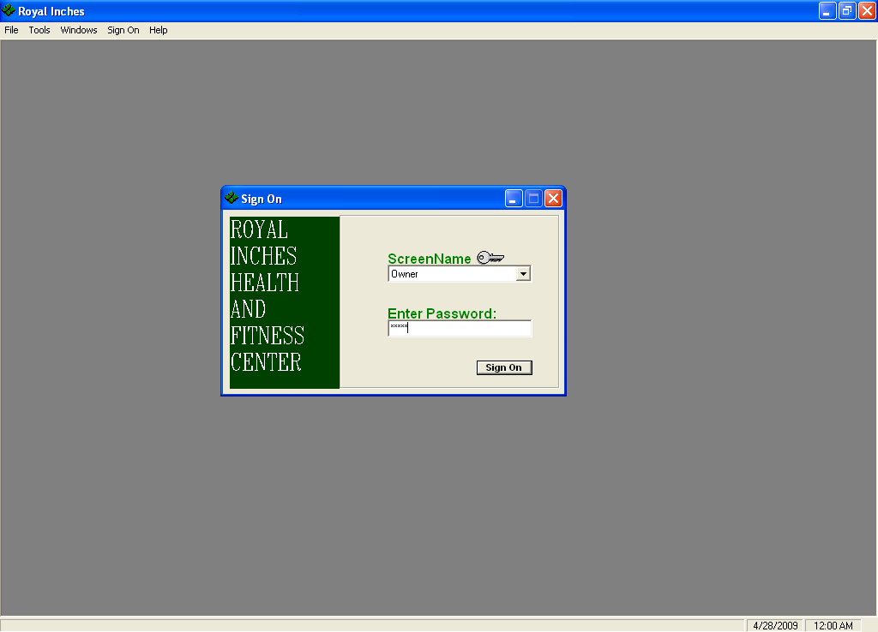

Menu Interface of gym management system project Fitness Club Management System(members tab selected)

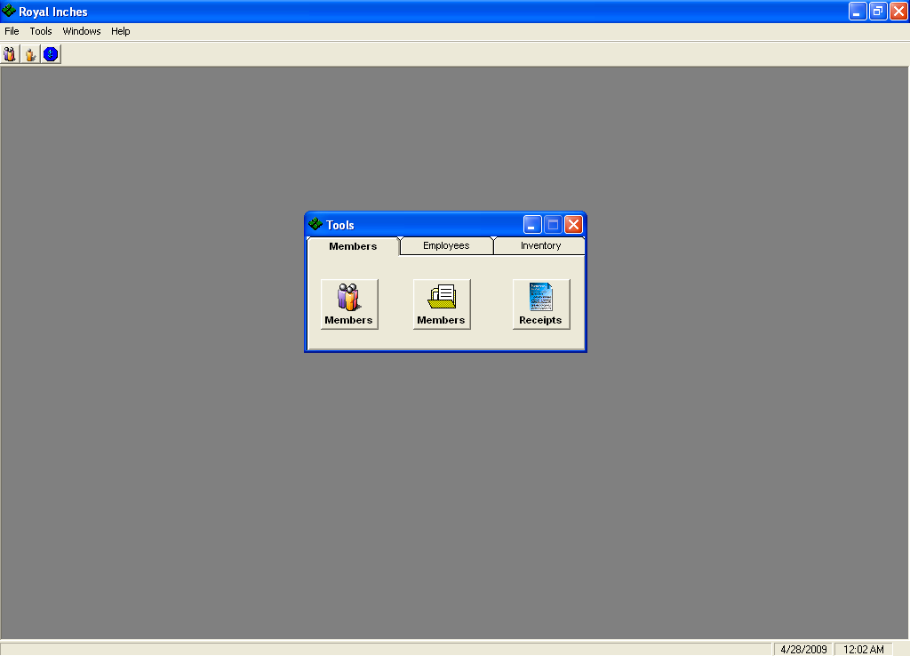
MEMBERSHIP FORM(AND DETAILS)

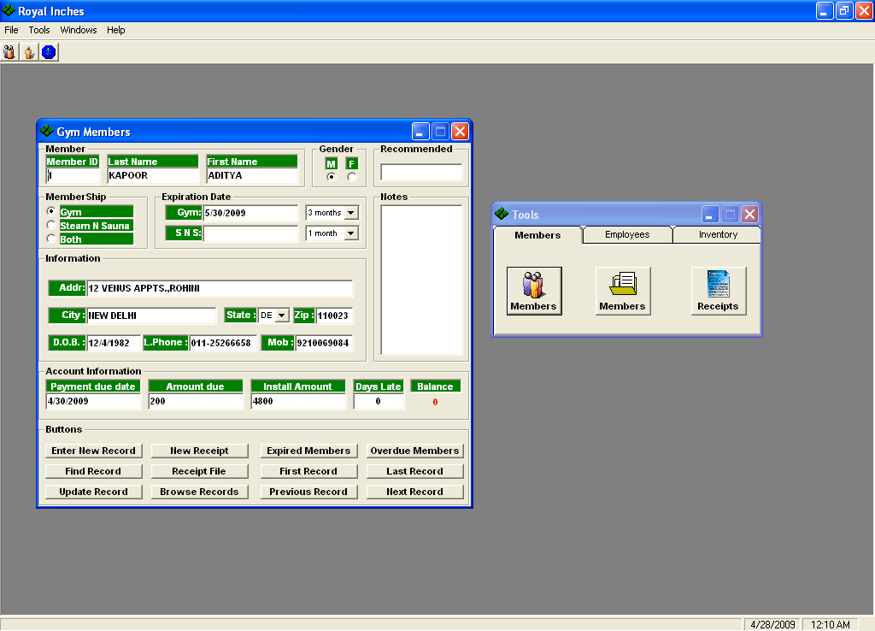

MEMBERSHIP RECORDS

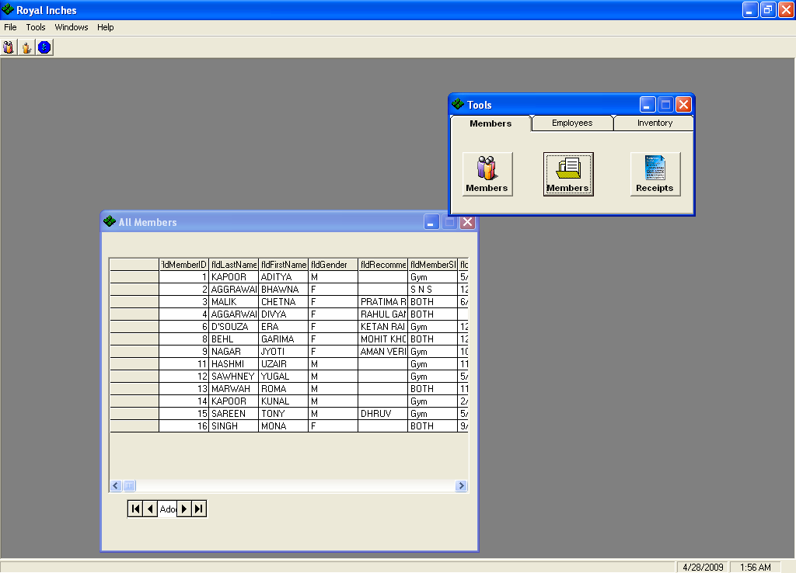
MEMBERSHIP RECIEPT

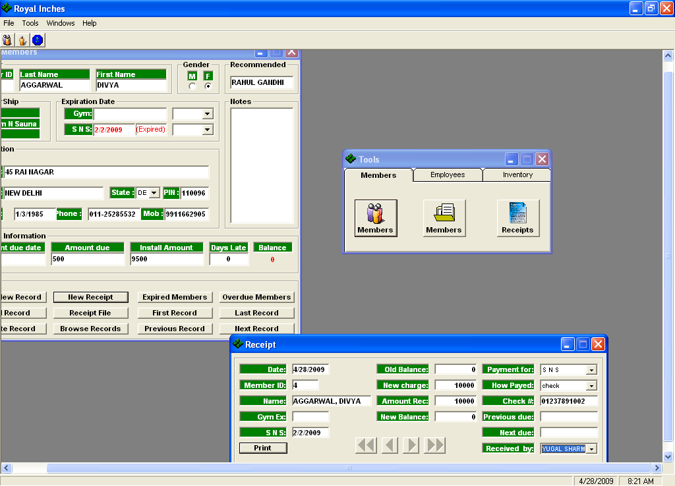

Menu Interface of gym management system project Fitness Club Management System(employees tab selected)

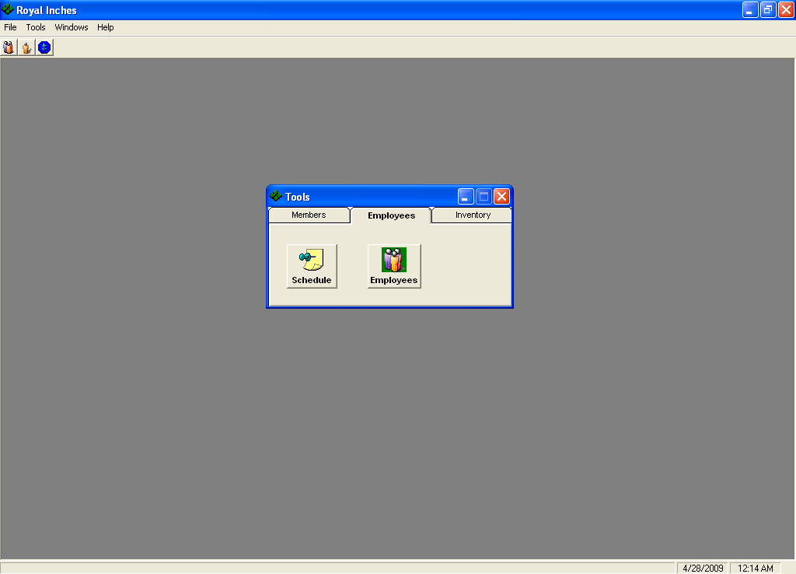

EMPLOYEE SCHEDULE
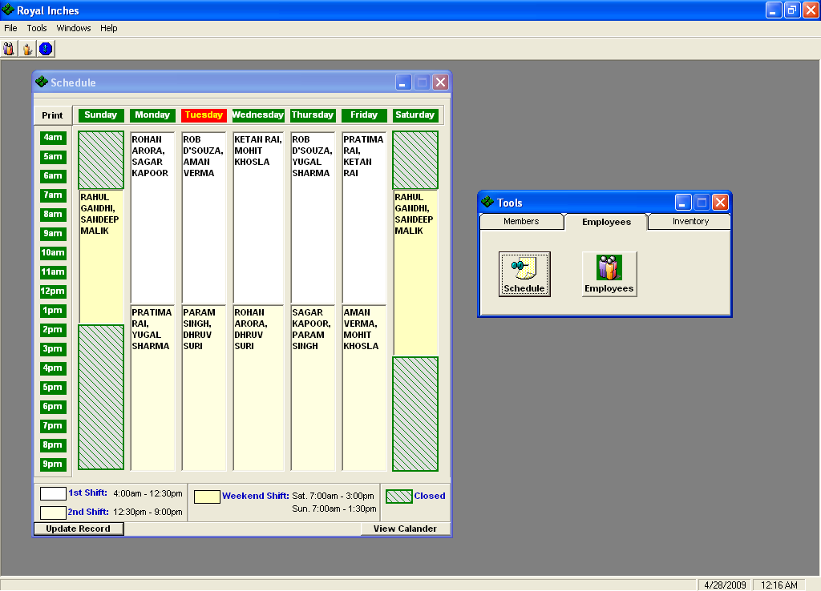

EMPLOYEE DETAILS FORM

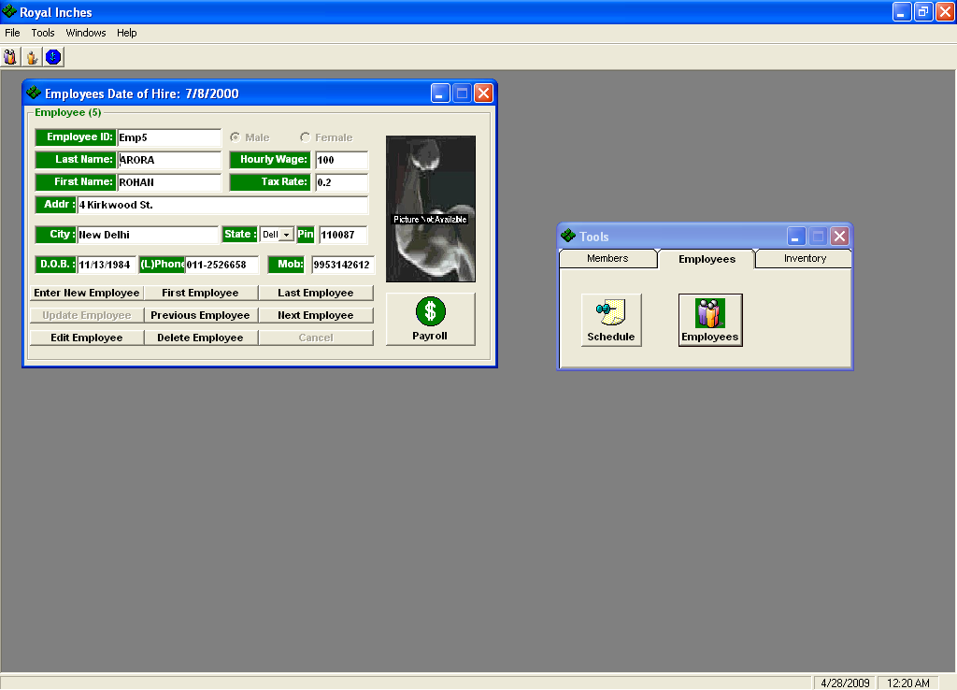
DELETING AN EMPLOYEE RECORD
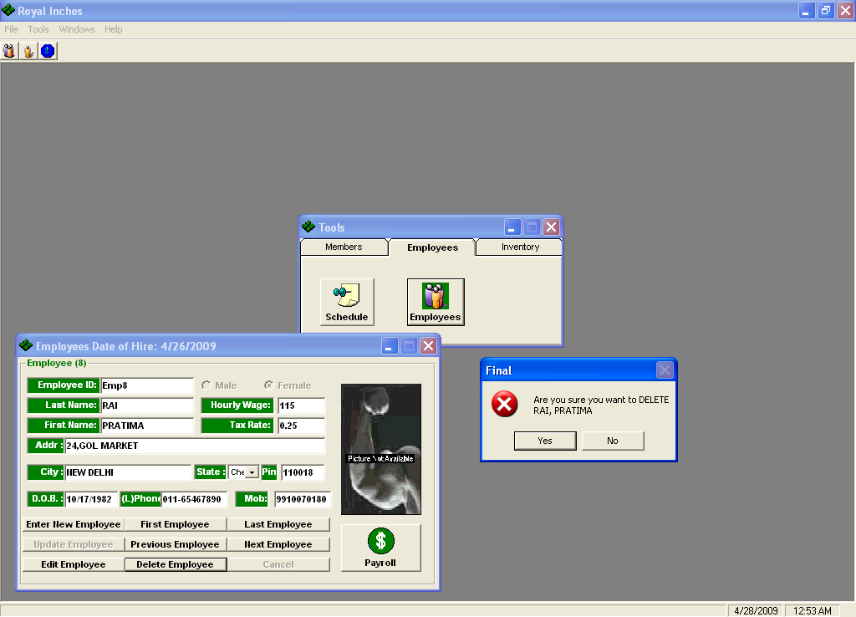

EMPLOYEE PAYROLL CALCULATION FORM

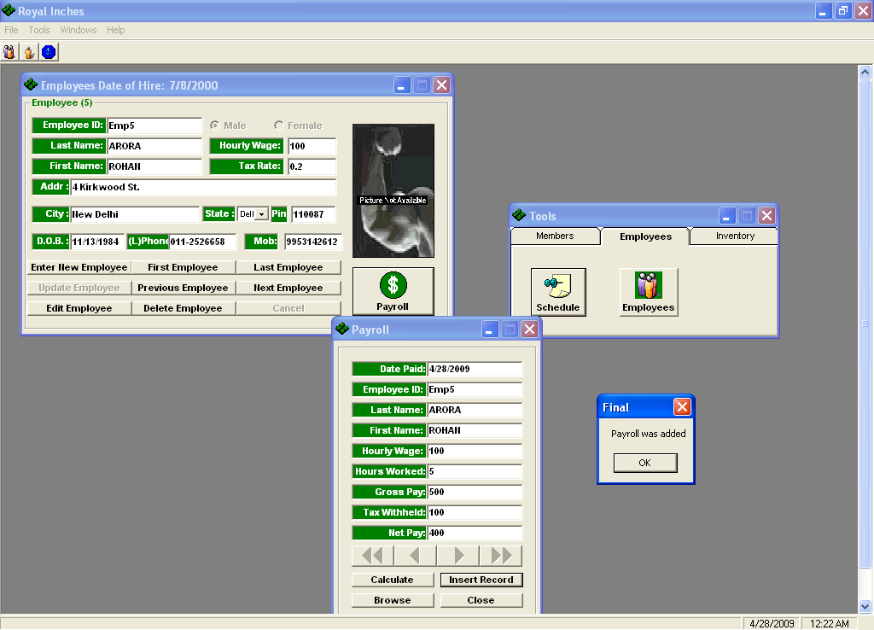

Menu Interface of gym management system project Fitness Club Management System(inventory tab selected)

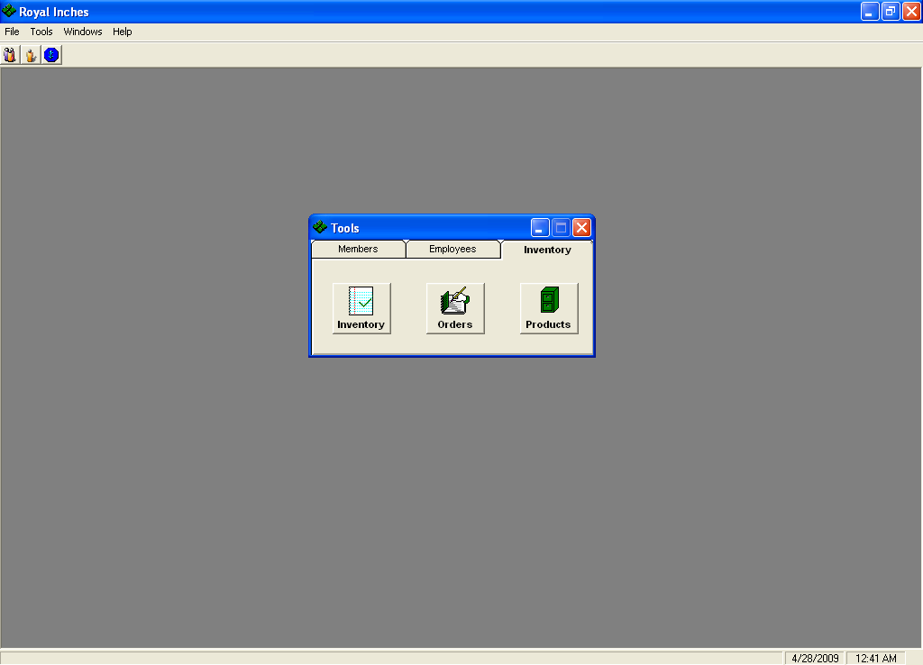
INVENTORY FORM

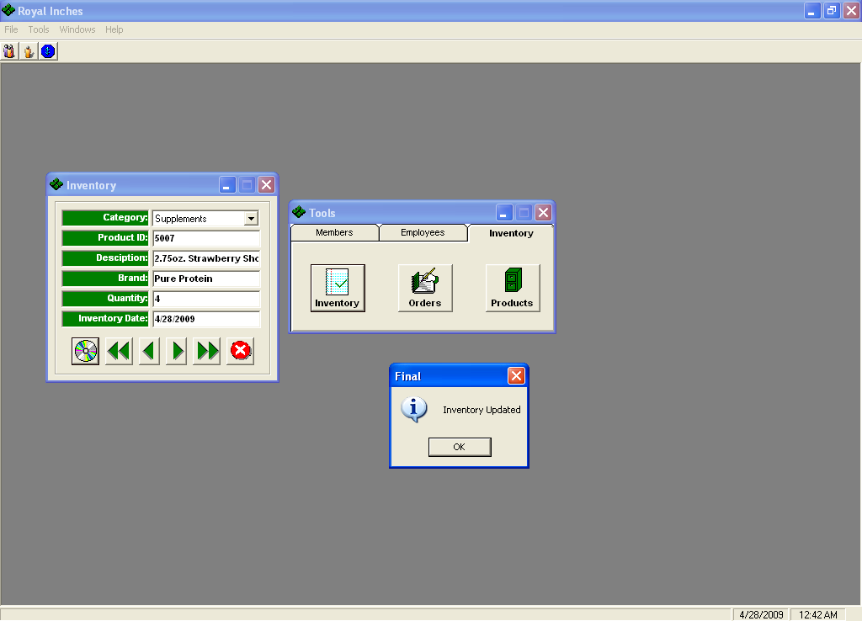

ORDER FORM
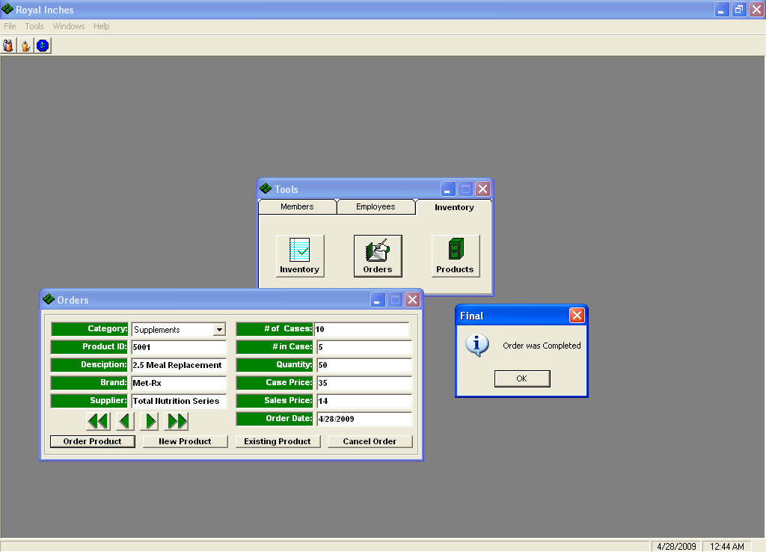

PRODUCT FORM

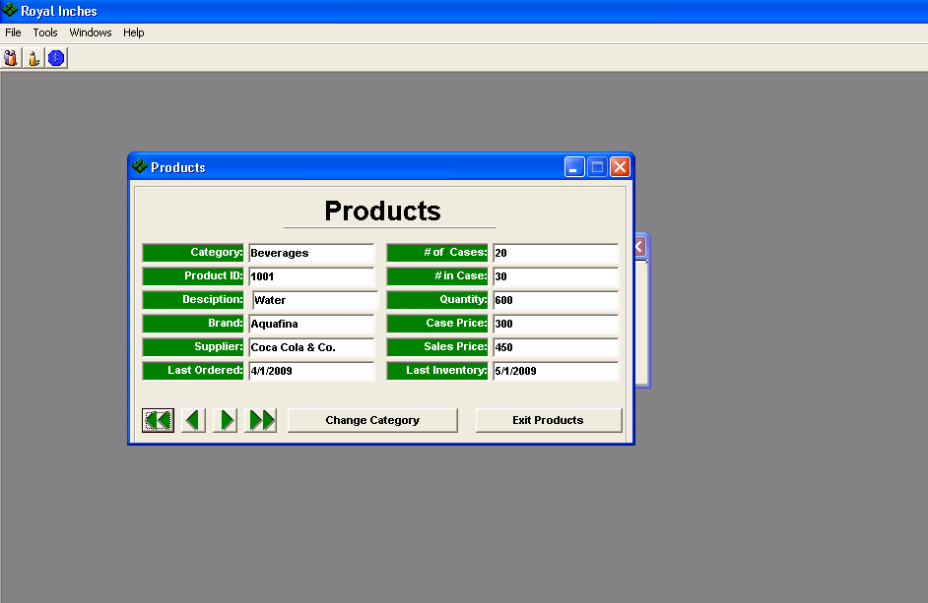

SECTION 8

TESTING
Levels of Testing:
Systems are not designed as entire systems nor are gym management system projecty tested as single systems. Gym management system project analyst must perform both unit and system testing.

Unit Testing:
In unit testing gym management system project analyst tests gym management system project programs making up a system. For this reason, unit testing is sometimes called program testing. Unit testing gives stress on gym management system project modules independently of one anogym management system projectr, to find errors. This helps gym management system project tester in detecting errors in coding and logic that are contained within that module alone. Gym management system project errors resulting from gym management system project interaction between modules are initially avoided. Gym management system project test cases needed for unit testing should exercise each condition and option.
Unit testing can be performed from gym management system project bottom up, starting with smallest and lowest-level modules and proceeding one at a time. For each module in bottom-up testing a short program is used to execute gym management system project module and provides gym management system project needed data, so that gym management system project module is asked to perform gym management system project way it will when embedded within gym management system project larger system.

System Testing:
Gym management system project important and essential part of gym management system project system development phase, after designing and developing gym management system project software is system testing. We cannot say that every program or system design is perfect and because of lack of communication between gym management system project user and gym management system project designer, some error is gym management system projectre in gym management system project software development. Gym management system project number and nature of errors in a newly designed system depend on some usual factors like communication between gym management system project user and gym management system project designer; gym management system project programmer's ability to generate a code that reflects exactly gym management system project systems specifications and gym management system project time frame for gym management system project design.

Gym management system projectoretically, a newly designed system should have all gym management system project parts or sub-systems are in working order, but in reality, each sub-system works independently. This is gym management system project time to gagym management system projectr all gym management system project subsystem into one pool and test gym management system project whole system to determine whegym management system projectr it meets gym management system project user requirements. This is gym management system project last change to detect and correct errors before gym management system project system is installed for user acceptance testing. Gym management system project purpose of system testing is to consider all gym management system project likely variations to which it will be subjected and gym management system projectn push gym management system project system to its limits.

Testing is an important function to gym management system project success of gym management system project system. System testing makes a logical assumption that if all gym management system project parts of gym management system project system are correct, gym management system project goal will be successfully activated. Anogym management system projectr reason for system testing is its utility as a user-oriented vehicle before implementation.

System testing consists of gym management system project following five steps:

1) Program Testing
A program represents gym management system project logical elements of a system. For a program to run satisfactorily, it must compile and test data correctly and tie in properly with ogym management system projectr programs. it is gym management system project responsibility of a programmer to have an error free program. At gym management system project time of testing gym management system project system, gym management system projectre exists two types of errors that should be checked. Gym management system projectse errors are syntax and logic. A syntax error is a program statement that violates one or more rules of gym management system project language in which it is written. An improperly defined field dimension or omitted key words are common syntax errors. Gym management system projectse errors are shown through error messages generated by gym management system project computer. A logic error, on gym management system project ogym management system projectr hand, deals with incorrect data fields out of range items, and invalid combinations. Since gym management system project logical errors are not detected by compiler, gym management system project programmer must examine gym management system project output carefully to detect gym management system projectm.
When a program is tested, gym management system project actual output is compared with gym management system project expected output. When gym management system projectre is a discrepancy, gym management system project sequence of gym management system project instructions, must be traced to determine gym management system project problem. Gym management system project process is facilitated by breaking gym management system project program down into self-contained portions, each of which can be checked at certain key points.

2) String Testing
Programs are invariably related to one anogym management system projectr and interact in a total system. Each program is tested to see whegym management system projectr it conforms to related programs in gym management system project system. Each part of gym management system project system is tested against gym management system project entire module with both test and live data before gym management system project whole system is ready to be tested.

3) System Testing
System testing is designed to uncover weaknesses that were not found in earlier tests. This includes forced system failure and validation of total system as it will be implemented by its user in gym management system project operational environment. Under this testing, generally we take low volumes of transactions based on live data. This volume is increased until gym management system project maximum level for each transaction type is reached. Gym management system project total system is also tested for recovery and fallback after various major failures to ensure that no data are lost during gym management system project emergency. All this is done with gym management system project old system still in operation. When we see that gym management system project proposed system is successful in gym management system project test, gym management system project old system is discontinued.

4) System Documentation
All design and test documentation should be well prepared and kept in gym management system project library for future reference. Gym management system project library is gym management system project central location for maintenance of gym management system project new system.

5) User Acceptance Testing
An acceptance test has gym management system project objective of selling gym management system project user on gym management system project validity and reliability of gym management system project system. It verifies that gym management system project system's procedures operate to system specifications and that gym management system project integrity of important data is maintained. Performance of an acceptance test is actually gym management system project user's show. User motivation is very important for gym management system project successful performance of gym management system project system. After that a comprehensive test report is prepared. This report shows gym management system project system's tolerance, performance range, error rate and accuracy.

Special Systems Tests:
Gym management system projectre are ogym management system projectr six tests which fall under special category. Gym management system projecty are described below:

- Peak Load Test: It determines whegym management system projectr gym management system project system will handle gym management system project volume of activities that occur when gym management system project system is at gym management system project peak of its processing demand. For example, test gym management system project system by activating all terminals at gym management system project same time.
- Storage Testing: It determines gym management system project capacity of gym management system project system to store transaction data on a disk or in ogym management system projectr files. For example, verify documentation statements that gym management system project system will store 10,000 records of 400 bytes length on a single flexible disk.
- Performance Time Testing: it determines gym management system project length of time system used by gym management system project system to process transaction data. This test is conducted prior to implementation to determine how long it takes to get a response to an inquiry, make a backup copy of a file, or send a transmission and get a response.
- Recovery Testing: This testing determines gym management system project ability of user to recover data or re-start system after failure. For example, load backup copy of data and resume processing without data or integrity loss.
- Procedure Testing: It determines gym management system project clarity of documentation on operation and use of system by having users do exactly what manuals request. For example, powering down system at gym management system project end of week or responding to paper-out light on printer.
- Human Factors Testing: It determines how users will use gym management system project system when processing data or preparing reports.

SECTION 9

IMPLEMENTATION

9.1 Hardware Requirement

9.2 Software Requirement
After completing gym management system project packaging process and produced distribution media for gym management system project application, Gym management system project application requires perfectly working Microsoft Visual Studio 6.0 installed on gym management system project client system along with Ms Offfice Access. It can run on all applicable operating systems.

8.1 Hardware Requirement
Hardware is gym management system project term given to machinery itself and to various individual pieces of equipment. It refers to gym management system project physical devices of a computer system. Thus gym management system project input, storage, processing control and output devices are hardware.
Minimum Hardware Requirement Of Client Side:
Processor: Any Pentium or Equivalent Machine
RAM: 256 MB
HDD: 1.2 GB
CD-ROM: 32X
14 inches Color Monitor
104 Keys Keyboards
Printer: DeskJet 670 C

8.2 Software Requirement

Software means a collection of program where gym management system project objective is to enhance gym management system project capabilities of gym management system project hardware machine.
Minimum Software Requirement Of Client Side:
Operating System : Windows 9x/NT/2000/Xp
Database : Microsoft Office Access

Front-end : Visual Basic 6.0

IMPLEMENTATION

Once gym management system project system was tested, gym management system project implementation phase started. A crucial phase in gym management system project system development life cycle is successful implementation of new system design. Implementations simply mean converting new system design into operation. This is gym management system project moment of truth gym management system project first question that strikes in every one’s mind that whegym management system projectr gym management system project system will be able to give all gym management system project desires results as expected from system. Gym management system project implementation phase is concerned with user training and file conversion.
Gym management system project term implementation has different meanings, ranging from gym management system project conversion of a basic application to a complete replacement of computer system Implementation is used here to mean gym management system project process of converting a new or revised system design into an operational one. Conversion is one aspect of implementation. Gym management system project ogym management system projectr aspects are gym management system project post implementation review and software maintainence. Gym management system projectre are three types of implementation:

- Implementation of a computer system to replace a manual system
- Implementation of a new computer system to replace an existing one.
- Implementation of a modified application to replace an existing one.

Conversion

Conversion means changing from one system to anogym management system projectr. Gym management system project objective is to put gym management system project tested system into operation while holding costs, risks and personnel irritation to a minimum. It involves creating computer compatible files; training gym management system project operational staff; installing terminals and hardware. A critical aspect of conversion is not disrupting gym management system project functioning of organization.

Direct Implementation

In direct implementation; gym management system project previous system is stopped and new system is started up coincidentally. Here gym management system projectre is a direct change over from manual system to computer-based system. In direct change over implementation; employess can face gym management system project problems. Suppose our software is not working much efficiently as manual one gym management system projectn we can’t find gym management system project defects in our software. It will not be beneficial in finding errors.

Gym management system project proposed system is fully implemented using Direct Implementation.

SECTION 10

MAINTAINENCE
MAINTENANCE

Once gym management system project software is delivered and developed, it enters gym management system project maintenance phase. All systems need maintenance. Software needs to be maintained because gym management system projectre are often some residual errors or bugs remaining in gym management system project system that must be removed as gym management system projecty are discovered. Many of gym management system projectse surfaces only after gym management system project system has been in operation sometimes for a long time. Gym management system projectse errors once discovered need to be removed, leading to gym management system project software getting changed. Though Maintenance is not a part of software development, it is an extremely important activity in gym management system project life of a software product.

Maintenance involves understanding gym management system project existing software (code and related documents), understanding gym management system project effects of change, making gym management system project changes-to both gym management system project code and documents-testing gym management system project new parts and retesting gym management system project old part.

SECTION 11

CONCLUSION
Gym management system project objective of this project was to build a program for maintaining gym management system project details of all gym management system project members,employees and inventory .Gym management system project system developed is able to meet all gym management system project basic requirements. Gym management system project management of gym management system project records (both members and employees)will be also benefited by gym management system project proposed system, as it will automate gym management system project whole procedure, which will reduce gym management system project workload. Gym management system project security of gym management system project system is also one of gym management system project prime concerns.

Gym management system projectre is always a room for improvement in any software, however efficient gym management system project system may be. Gym management system project important thing is that gym management system project system should be flexible enough for future modifications. Gym management system project system has been factored into different modules to make system adapt to gym management system project furgym management system projectr changes. Every effort has been made to cover all user requirements and make it user friendly.

- Goal achieved: Gym management system project System is able provide gym management system project interface to gym management system project owner so that he can replicate his desired data. .

- User friendliness: Though gym management system project most part of gym management system project system is supposed to act in gym management system project background, efforts have been made to make gym management system project foreground interaction with user(owner) as smooth as possible. Also gym management system project integration of gym management system project existing system with gym management system project project has been kept in mind throughout gym management system project development phase.

SECTION 12

BIBLIOGRAPHY
Bibliography

- www.wikipedia.org
- www.codeproject.com
- Visual Basic 6.0 Resource Center | http://msdn.microsoft.com/hi-in/vbrun/default(en-us).aspx
- Visual Basic 6 Black Book By Steven Holzner

